25 AUGUST 2019

USING DESIGN THINKING TO SUPPORT RESEARCH IN CHALLENGING CONTEXTS
A Design Thinking Toolkit to Inform Research in Challenging Contexts

Prepared by:

Susan Crichton, University of British Columbia, Canada
Chrisna Botha-Ravyse & Sarah J Moss, North-West University, South Africa

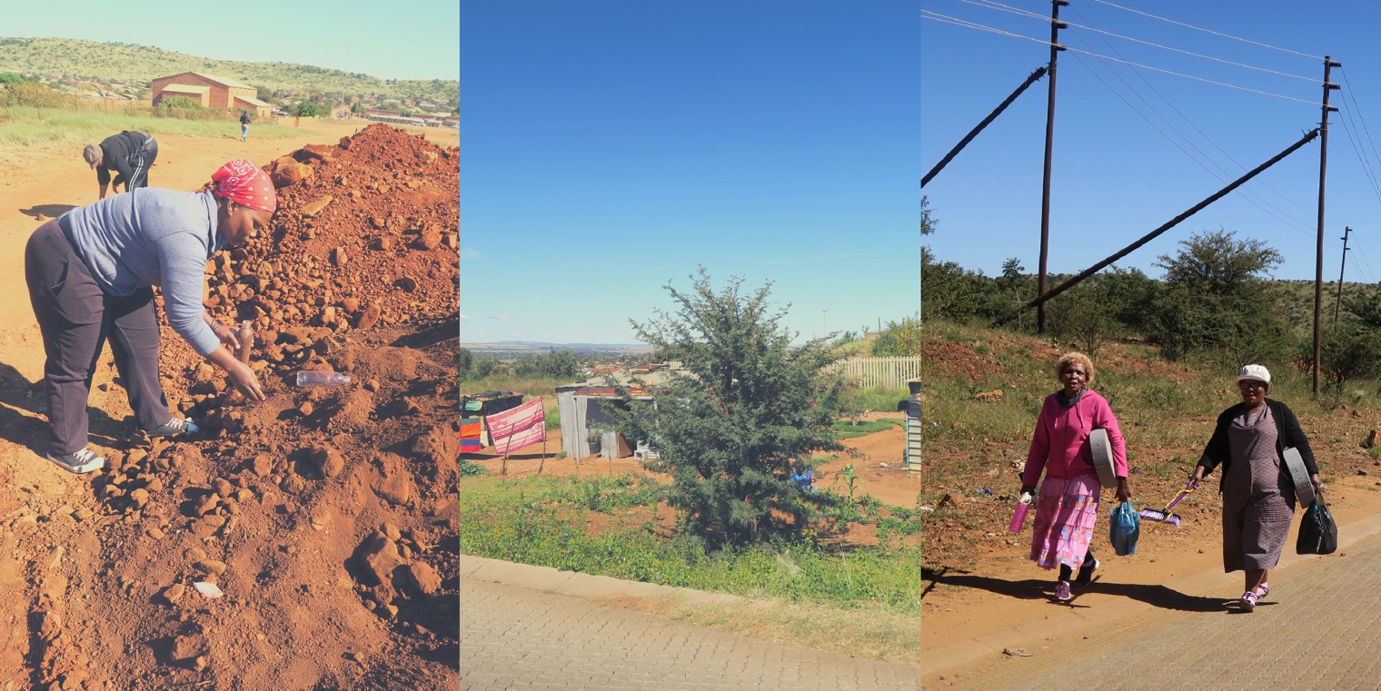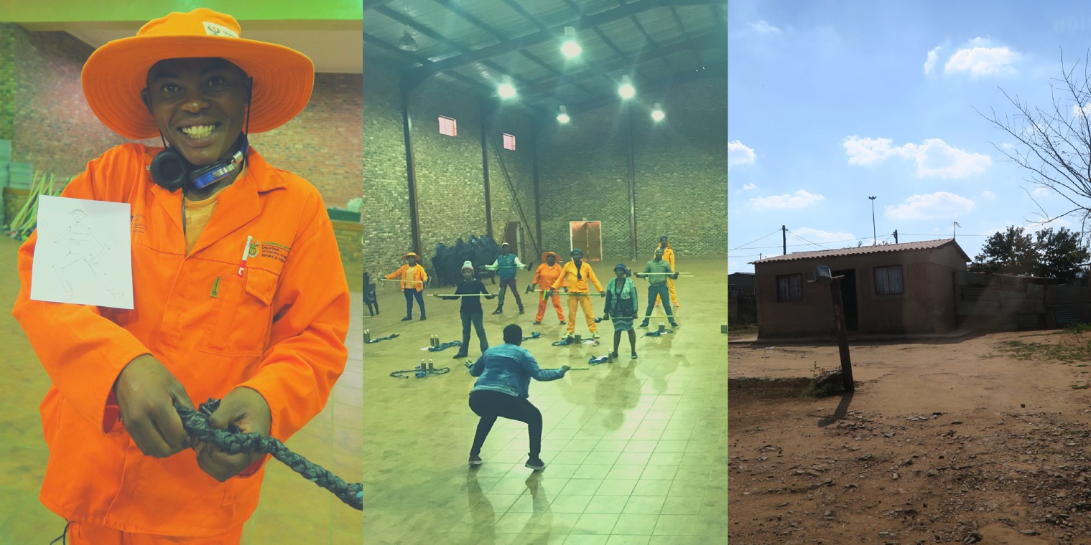ABOUT THE TOOLKIT

Design Thinking is typically viewed as a human-centred approach used to foster innovation, creativity and change. It has been used in the industry to inform the design of products and services. Design Thinking is also effective in research activities addressing wicked or complex problems. A toolkit provides context and resources to enable researchers to develop their research projects situated in challenging contexts. This toolkit was created from a challenging context set in an impoverished community in South-Africa.

i
Toolkit for challenging contexts

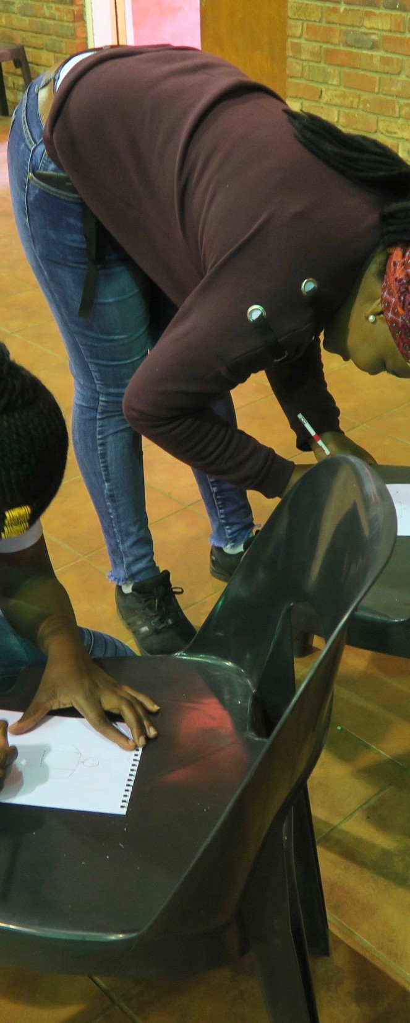TABLE OF CONTENTS

BACKGROUND
  - What Is Design Thinking?
  - Design Thinking’s Origins
  - Design Thinking as a Research Methodology 1.4 Situating Design Thinking Challenging Contexts 1.5 Tips For Conducting Research In Challenging
Contexts
1.6 Obtaining Ethical Approval for Research in Challenging Contexts

THE DESIGN THINKING PROCESS
  - Developing Empathy Starts with Learning to Ask Good Questions
  - Moving from Ideation to Prototyping

- COMPONENTS OF A GOOD DESIGN CHALLENGE 3.1 Tips on Crafting Design Challenges as
Provocations for Research
3.2 A Sample Design Challenge - Sourcing, Preparing and Serving a Healthy Meal

REFERENCES

- APPENDICES
Appendix 1: Tips for facilitating a design thinking research session
Appendix 2: Makerspaces by maker/prototype intentions and safety issues
Appendix 3: Tips for making and fastening
Appendix 4: Tips for materials and resources by maker intentions
Apendix 5: Sample participant consent form Appendix 6: Tips for digital documentation

Toolkit for challenging contexts ii

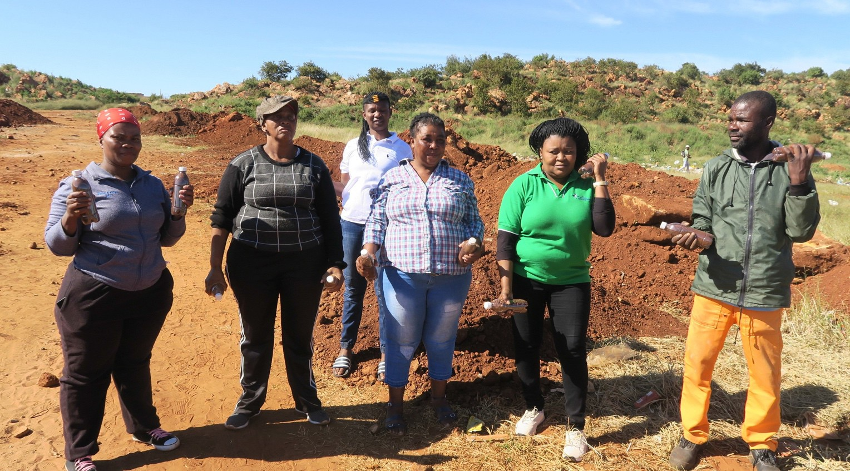USING DESIGN THINKING TO SUPPORT RESEARCHINCHALLENGING CONTEXTS

1. BACKGROUND TO OUR APPROACH

Our international research team came together in 2017. The focus of our work was to explore how the use of mobile technologies might enable health care providers to aid patients in improving their health in real-time while empowering both the providers and their patients’ ways in which they could personalise their healthcare options and monitor their progress. Our team brings a diverse skillset and background to our project, and we have adopted a Design Thinking methodology to guide our work.

We developed this toolkit to share our approach. Our research is positioned within the Health Science field and is situated in a challenging context in South Africa – an informal settlement on the outskirts of Potchefstroom.

Toolkit for challenging contexts 1

What Is Design Thinking?

Design Thinking is a human-centred process honed at Stanford University’s d.School (https://dschool.stanford.edu/). The process is used in business, schools, organisations, and numerous other settings to create change and foster innovation. Design Thinking, as a process, encourages its users to develop a positive, proactive and optimistic stance toward addressing complex problems.
Design Thinking supports divergent, lateral thinking – thinking that enables problem finding rather than quick, often short-sighted, problem-solving. Design Thinking encourages users to realise it is possible “… to creatively attack the world’s greatest problems and meet people’s most urgent needs” (Hatch, 2014). Sites like OpenIDEO.org share projects situated in the service of the public good.
Design Thinking can be used to develop core abilities, such as:

- Navigate ambiguity - ability to persist with the discomfort of not knowing;
- Learn from others – the ability to emphasise and embrace diversity;
- Synthesise information – ability to make sense of information and find insight and opportunity;
- Experiment rapidly – the ability to quickly generate ideas in written, drawn or built forms;
- Move between concrete and abstract – ability to move between needs, ideas, and define ideas;
- Build and craft intentional – ability to thoughtfully make/construct ideas into tangible, shareable forms;
- Communication deliberately – the ability to form, capture, and related stories, ideas, concepts, reflections and learnings to diverse audiences; and
- Design – ability to recognise a project as a design challenge and then decide on people, tools, techniques required to tackle the project (https://dschool.stanford.edu/about/#about-8-core-abilities).

As described by d.School, Design Thinking typically has five inter-related, iterative steps. These steps are flexible, and while often experienced within a short sprint (https://dschool- old.stanford.edu/groups/designresources/wiki/ed894/the_giftgiving_project.html), they can be adapted to various applications and stopped and started to allow for information gathering, consulting, and other supporting research focused activities.

Toolkit for challenging contexts 2

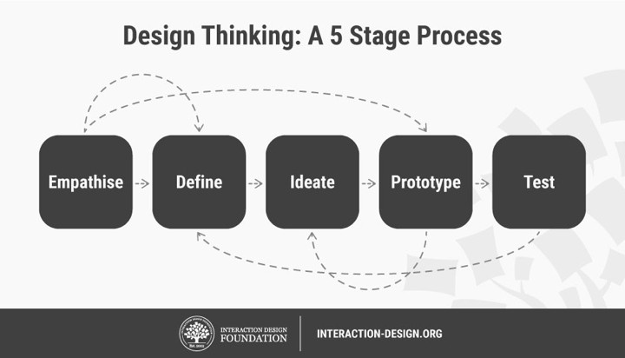Figure 1: A schematic representation of the five inter-related, iterative steps of Design Thinking According to Tim Brown, CEO of IDEO (www.ideo.org), becoming a design thinker helps us:
- Gain empathy for others and imagine the world from multiple perspectives;
- Engage in integrative thinking and learn to exploit the potential of various ideas and constraints to create something new;
- Maintain and gain optimism, suggesting no matter how challenging the constraints of a given problem, at least one potential solution is better than the existing alternatives;
- Engage in experimentalism by posing questions and exploring constraints in creative ways that proceed in entirely new directions; and
- Collaborate with others, recognising the strength of the Japanese proverb that “None of us is as smart as all of us!”

Design Thinking’s Origins

The Interaction Design Foundation (https://www.interaction-design.org/literature/article/ design-thinking-get-a-quick-overview-of-the-history) provides an overview of the history/ evolution of Design Thinking, dating back to initial attempts in the 1960s to turn design into a process. This effort corresponded with Buckminster Fuller’s call for a ‘design science revolution', based on science, technology and rationalism, to overcome the human and environmental problems that he believed could not be solved by politics and

Toolkit for challenging contexts 3

economics" (Cross, 2001). At this same time, Horst Rittel, a Design Theorist known for coining the term ‘Wicked Problems’ (i.e., extremely complex/multi- dimensional problems), wrote and spoke extensively on the subject of problem-solving in design. In particular, Rittel focused on the application of design methodologies in tackling Wicked Problems and how they were influential in the work of many design practitioners and academics of the time. Wicked problems are at the very heart of Design Thinking because it is precisely these complex and multi-dimensional problems that require a collaborative methodology that involves gaining a deep understanding of humans (Dam & Siang, n.d.).

During the 1970s and 1980s, Cognitive scientist and Nobel Prize laureate for economics, Herbert Simon, contributed many ideas regarded now as tenets of Design Thinking. He is noted to have spoken of rapid prototyping and testing through observation, concepts which form the core of many design and entrepreneurial processes. Prototyping also forms one of the major phases of the Design Thinking process. A large portion of his work focused on the development of artificial intelligence and whether human forms of thinking could be synthesized.

Robert H. McKim, best described as an artist and engineer, focused his energies more on the impact visual thinking and design methods for solving problems with an emphasis on combining the left and right brain modes of thinking, to bring about a more holistic form of problem solving. In 1982, Nigel Cross discussed the nature of designers problem-solving in his seminal paper Designerly ways of knowing. Cross compared designers’ problem solving to the non-design related problem solutions we develop in our everyday lives (Dam & Siang, n.d.).

In 1991, IDEO was formed and featured a design process modeled on the work developed at the Stanford Design School. IDEO is widely accepted as one of the companies that brought Design Thinking to the mainstream; developing their own customer-friendly terminology, steps, and toolkits over the years, they have allowed those not schooled in design methodology to quickly and easily become oriented with the process. [Currently,] Design Thinking is taught at the Stanford School of Design, or the d.school. At present, the Design Thinking movement is gaining ground rapidly, with pioneers like IDEO and d.school formalizing a path ahead for others to follow. Other prestigious universities, business schools and forward-thinking companies have adopted the methodology to varying degrees, sometimes re-interpreting it to suit their specific context or brand values (Dam & Siang, n.d.).

Toolkit for challenging contexts 4

1.3 Design Thinking as a Research Methodology

As a research methodology, Design Thinking can be found in the work of Participatory Design (https://medium.com/the-making-of-appear-in/participatory-design-as-a-research-method- bc42c01943b1) and Collective Impact (https://ssir.org/articles/entry/collective_impact). Both these approaches place the individuals being studied at the heart of the work and views them as participants in both the process and product. Both Participatory Design and Collective Impact include participants in all aspects of the research from setting the research agenda and questions to determining metrics for evaluation and terms for data analysis. Appendix 1 in this resource shares a tested method we have used to facilitate Design Thinking as a research method.

The Design Thinking process typically starts with a real-world challenge. Rather than hurrying to find a quick solution or trying to replicate generalized solutions to the challenge Immediately, the Design Thinking process is used as a way to being to find and identify the source of the challenge. It engages the researcher(s) with the people experiencing the challenge and the factors that created it. The Design Thinking process is situated in the belief that experiencing the challenge often hold at least part of the answers.

The Design Thinking process is especially valuable when it is used to investigate complex or wicked research problems. Wicked problems are defined as problems that seem impossible to solve – problems like the majority of the current United Nations Sustainable Millennium Goals (https://sustainabledevelopment.un.org/?menu=1300). Ten characteristics of wicked problems include

- There is no definitive formula for a wicked problem.
- Wicked problems have no stopping rule, as in there’s no way to know your solution is final.
- Solutions to wicked problems are not true-or-false; they can only be good-or-bad.
- There is no immediate test of a solution to a wicked problem.
- Every solution to a wicked problem is a ‘one-shot operation’; because there is no opportunity to learn by trial-and-error, every attempt counts significantly.
- Wicked problems do not have a set number of potential solutions.
- Every wicked problem is essentially unique.
- Every wicked problem can be considered a symptom of another problem.
- There is always more than one explanation for a wicked problem because the reasons vary greatly depending on the individual perspective.
- Planners/designers have no right to be wrong and must be fully responsible for their actions (Wicked Problems, n.d.).

Toolkit for challenging contexts 5

Examples of a complex or wicked problem situated within the field of Health and Wellness research might include, but are not limited to the following questions:

- How might understanding the components of a healthy meal assist families in preparing and eating foods that support active, healthy living? Further, what barriers do families in extreme poverty face in attempting to prepare and consume meals that support active, healthy living?
- What types of outdoor recreation/fitness equipment would be appropriate for multi-age, community accessible wellness and fitness activities?
- What affordable and durable equipment would support the development and fitness of high- performance athletes while encouraging others to engage in active lifestyles?
- What age-appropriate, simple, equipment-free, daily fitness activities could teachers introduce and use as part of their classroom routines to encourage wellness and active living for themselves and their students? How can students and teachers be encouraged to sustain a commitment to wellness and fitness?
- What inexpensive and easy to make assistive equipment could be developed for home useto support rehabilitation and wellness amongst elderly or vulnerable members of our communities?

Please see Section 3, which shares how you might craft complex or wicked research questions in the form of a Design Challenge. Section 3.2 offers an example of using Design Thinking in a Health Science research context. The approach suggested here is a modification of the d.School process that also uses a minimal amount of resources and materials. To understand the actual d.School approach for Design Thinking, please explore The Gift-Giving Project as it provides resources and a video guide.

(https://dschool- old.stanford.edu/groups/designresources/wiki/ed894/the_giftgiving_project.html

Toolkit for challenging contexts 6

1.4 Situating Design Thinking in Challenging Contexts

We use the term challenging context in our work (Crichton, 2013) rather than morecommonly used terms such as developing world, third world, global south, or low-income area. We know that challenging contexts exist everywhere. We believe the term challenging contexts is more generous in its terminology as it recognises the universal issues the world’s citizens face, at various times and to various degrees. A recent World Economic Forum article (May, 2019) supported our position when it stated:

“Picture a country where a fifth of the population lives in poverty. People have to choose between eating or heating their homes and children go to school hungry. Homelessness is rising. And basic services are in crisis, leaving many struggling to cope.”

This is the damning indictment, delivered by a UN official, not of a developing economy or war- torn nation but of the UK – the world’s fifth-biggest economy (Edmond, May 2019, 1 & 2).

We define challenging contexts as settings in which individuals, due to a variety of circumstances, conditions or environmental constraints, do not have access to consistently available and affordable electricity, nor do they have access to many or all of the following:

- reliable, unfiltered or uncensored internet
- previous formal learning and/or opportunities for ongoing formal learning that support individual learning needs;
- non-formal, yet appropriate learning opportunities;
- participation in learning activities due to cultural or religious reasons; and
- transportation and mobility.

In many challenging contexts, other access issues are linked directly to poverty such as inadequate health care systems, fees for service, low wages, or inappropriate clothing to engage in specialized work (i.e., safety equipment, etc.). While this list is not exhaustive, it does reflect the lived experience of all too many marginalized people globally. Colleagues in East Africa contributed additional challenges impacting marginalized or vulnerable
populations, suggesting challenges related to access to:

  - clean water and adequate sanitation,
  - fair and just leadership,
  - adequate nutrition and safe food supply,
  - a safe environment free from hostilities and violence, and
  - support for the disabled (Crichton, 2013, p. 2)

Toolkit for challenging contexts 7

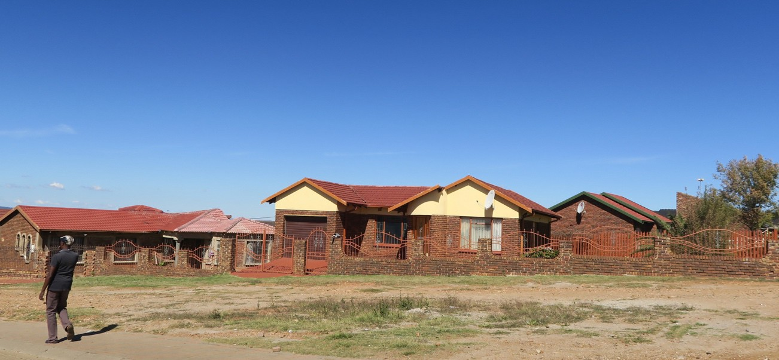Unfortunately, the conditions identified above are all too commonly experienced in the world today, and they require respectful consideration, especially when engaging these populations in research and community-based activities. “In fact, the literature suggests that initiatives and organizations (including universities and NGOs) must first recognize the constraints imposed by these challenges and then attempt to ameliorate them by providing appropriate actions and activities that minimally disrupt the context and populaces’ lives” (Bourne, Crichton, & Carter, 2015).

Toolkit for challenging contexts 8

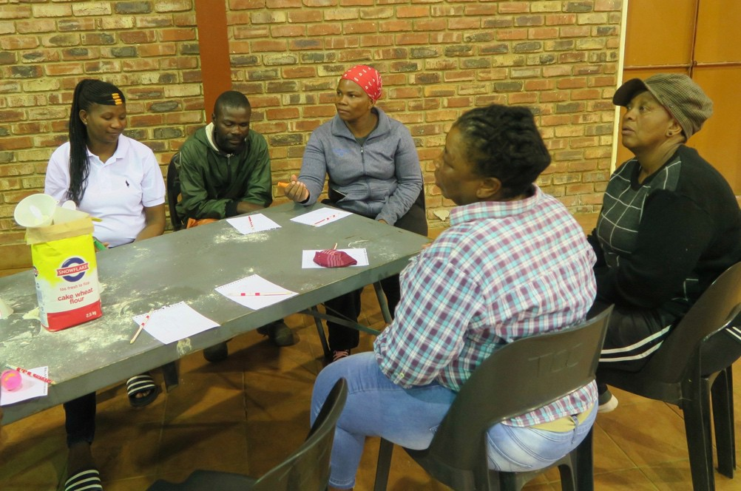

When situating research in challenging contexts, the researcher must pause and consider the importance of place and begin to engage in the anthropological act of making the familiar strange and the strange familiar (Spiro, 1990). Citing Lévi-Strauss, Spiro suggests being betwixt and between the researcher’s potentially privileged context and the research participant’s challenging context rarely allows the researcher or those participating in the research to be on neutral terms (p. 58). The very act of transitioning between the two contexts, and in making the familiar and the strange, requires the researcher “to come to view the familiar with a greater degree of objectivity than would otherwise be the case” (p. 48). Further, one might suggest that while the researcher may not end up fully understanding the many and varied nuances of the contextual challenges, s/he might end up knowing enough to ask more in-depth questions and allow both parties (researcher and participants) to act with a sense ofagency.

We found from our work that when we acknowledge the complex space that is created by living and researching in multiple contexts, we as academics and researchers are charged to do our best work. Our place of privilege as public intellectuals and academic leaders requires us to ensure that work that counts are counted and respected equally within the academy and the community from which it was informed. There is a much needed reciprocity required to allow the research participants to gain value from the research.

The additional time required to acknowledge and begin to understand the challenges raises
Toolkit for challenging contexts 9

another issue. Typically research projects are designed to address a gap in the literature and meet the needs of funders and institutional/academic interests, which often allows the researchers to spend only short periods directly in the challenging contexts. These shortvisits risk not allowing the researchers and the participants to develop significant understanding of cultural or contextual factors of the various actors, and the opportunity to engage deeply with the host community is compromised (Woolf, 2006).
Our experience, and the critical discourse surrounding research projects located in challenging contexts, suggests the need for greater attention to design, methodology, and impact paid to projects impacting vulnerable communities and marginalized individuals (Woolf, 2006), and for ensuring that needs and objectives of those being researched remain central to the project. Therefore, it seems critically important that when positioning research projects inchallenging contexts, the projects must be both purposeful and reciprocal to attempt to provide value to all concerned.

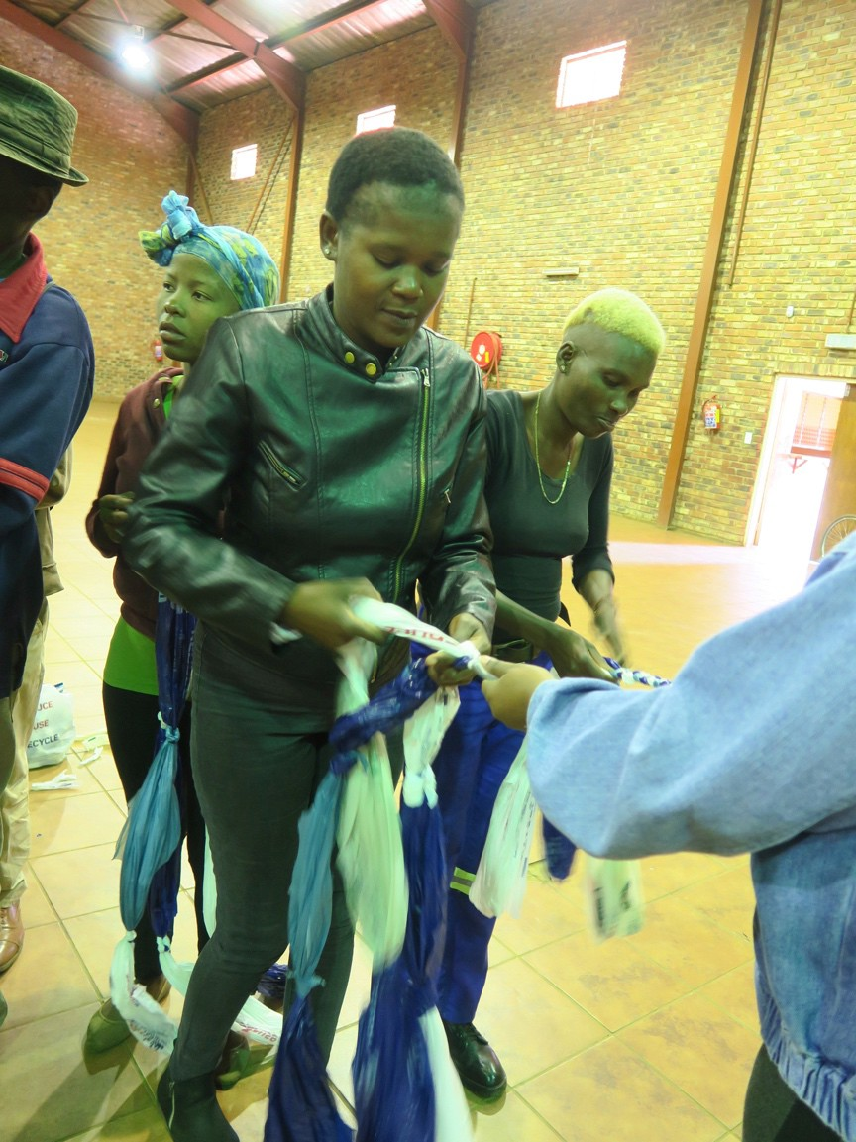

Toolkit for challenging contexts 10

1.5 Tips for Conducting Research in Challenging Contexts

Our research and work in various challenging contexts, ranging from North America to Africa to Asia and beyond, suggest researchers often find themselves outside of their comfort zones and becoming the other or the outsider in the challenging context (Hammersley & Atkinson, 1995). Hammersley and Atkinson (1995) remind us of the degree to which reflexivity (self- awareness) is required in the field, noting “the orientations of researchers will be shaped by their socio-historical locations, including the values and interests that these locations confer upon them” (p. 16). Further, they caution, when studying an unfamiliar setting, the [researcher] is also a novice. Whenever possible, he or she must put him- or herself into the position of being an ‘acceptable incompetent,’ as Lofland (1971) neatly describes it. It is only through watching, listening, asking questions, formulating hypotheses, and making blunders that the [researcher] can acquire some sense of the social structure of the setting and begin to understand the culture(s) of participants (p. 99 – 100).

Embracing the notion of becoming the other or outsider in the challenging context, the researcher must embrace the goodness, limits, problems and challenges of the contexts in which they work. The following tips are offered in the spirit of generosity and inclusion for both research participants and researchers. These tips have evolved from our practice (Crichton, 2013; Moss & Cameron, 2015), and we encourage other researchers to contribute to this list.

When working in Challenging Contexts, researchers need to:

- Observe the established work setting and clarify the reasons for specific actions. Through careful observation an independent opinion will be formed;
- Foster empathy amongst partners - researchers and participants, being mindful of the context, gender, religion, customs, and other confounding variables of the social and environmental context;
- Establish trust through words and actions;
- Develop a predictable workflow for all concerned;

- Set and manage expectations, recognizing the researcher is often a victim of previous researchers’ practices (i.e., gifts, payment, ways of working, or services that are discontinued);
- Move slowly and make many observations – to work vicariously and continually learn from the context (i.e., what are the characteristics of participants and how can we come to understand / respect one another’s culture and context);

Toolkit for challenging contexts 11

- Understand time the sense and respect of time in the various contexts;

- Think about the impact / sustainability of the research intervention, if the project is introducing an innovation or a different approach in an established context;
- Develop community based / situational questions;

- Be language specific when speaking with participants and if introducing an intervention (i.e., be mindful of tone, accent, syntax); Be flexible, open-minded and have a Plan B;
- Act within the interests of the participants in mind;
- Stay focused;
- Stay within scope of professional training and practice;
- Be scrupulously ethical;

- Do not assume that the gatekeeper have informed all involved about the researcher team visits and data collection. You might have to explain your purpose often to multiple role players;
- Have a diverse team in terms of culture and language skills;

- Recognize that health research is, by its nature, exploitive - people give their time; animals give their lives, so act responsibly;
- Recognize people living in low resourced communities may be vulnerable and particularly open to exploitation by researchers. People living in conditions with a lack of housing, nutrition, education, sanitation, and transportation, may have different purposes in life than those living in more affluent contexts;
- Understand culture and context, barriers and beliefs. Objective measures of interest to researchers are not enough when conducting data collection within communities. Researchers need to identify outcomes of importance to participants so that the research carries some value and meaning for the participants themselves;
- Provide a degree of reciprocity. Researchers collect data from communities, and through their research need to give something back. Too often the final outcome of a research project within a community is a peer-reviewed publication, which is an achievement for the researchers but brings little or no transfer of knowledge from the academic findings to the implementation within communities where the research was conducted;

Toolkit for challenging contexts 12

- Recognize tribal and / or hierarchical structures realizing that these structures may be needed to gain access to the community;
- Engage with the community at all levels to ensure relevance of your research;
- Understand relevant cultural traditions and beliefs for engagement;

- Follow the community’s social rules. Know who to engage at each stage of research for support and permission;
- Speak the local language or include a native language speaker on the research team;

- Be aware that not all languages have the vocabulary to express their thoughts in technical terms or understandable phrases.
- Use validated questionnaires for the specific population under investigation;

- Be flexible and open-mined, recognizing the researcher’s plans might not proceed as scheduled, and the research results might be surprising;
- Try to “keep one foot in each world”, so that you can connect with participants in their reality and simultaneously draw the information they give you into scientific documentation;
- Have empathy and compassion for people participating in the research and never lose sight of those people in the quest for good data;
- Develop persistence to continue with the research in the face ofbarriers;

- Maintain a sound clinical knowledge base within the research team and be sure to stay within your scope of practice; and
- Work with some good friends to buoy you along. Do not do this kind of research alone, remembering challenging contexts are challenging for all concerned.

Obtaining Ethical Approval for Research in Challenging Contexts

Often challenging contexts are a popular place for research in any given country as these contexts provide researchers with landscapes that house the significant issues of our times (i.e., poverty, drug addiction, homelessness, disease and hunger) and provide access to the most vulnerable people that possibly provide answers to these issues. It is therefore important that participants are rewarded for their time in a way that truly shows gratitude and respect for both the information but also the time used to gain the information.

Compensation, of any type, should be clearly expressed in the consent form so that it cannot be seen as bribery (Appendix 5). Every researcher knows that Informed Consent is an integral

Toolkit for challenging contexts 13

part of the research process. However, consent goes further than just informing participants and getting their permission to participate. It is also to ensure that a research team does not leave a community hanging in terms of what has happened to their information / experiences and to ensure that while gathering, analyzing and using the data, the researchers also added value to participants’ contributions.

In the research project shared as an example in this toolkit, specific context permission was also needed from the Department of Health Provincially, at district level and the participating clinics. Gatekeepers were identified to serve as the protectors of the participants from being exploited. Coupled with consent from the individual participants, this additional level of consent helped to ensure cooperation from the people on the ground and the gatekeepers in the various organization and is essential if a trust relationship is to be built.

Language issues can also be a problem, and therefore it can be important to have a native speaker on the team. Language issues include both the language itself as well as dialect, accent, and word usage. Many researchers speak in a rather stilted, academic way which lay participants may find difficult to understand – even with direct translation being available. In non-western languages, the vocabulary are lacking to express the information within the correct context.

On a practical level it was important to verbally explain what will be done and what will be expected of participants. In the case of the research shared in this toolkit, we had the community health care workers and the shift nurses available to ensure that everything was explained appropriately and only then did we ask the participants to sign the consent forms. For those who were not able to sign an inkpad was available to obtain a fingerprint.

It is also important in this process to ensure that participants consent to the taking of pictures that will be used as data, images to inform data, and / or images to illustrate key points in data presentation.

Toolkit for challenging contexts 14

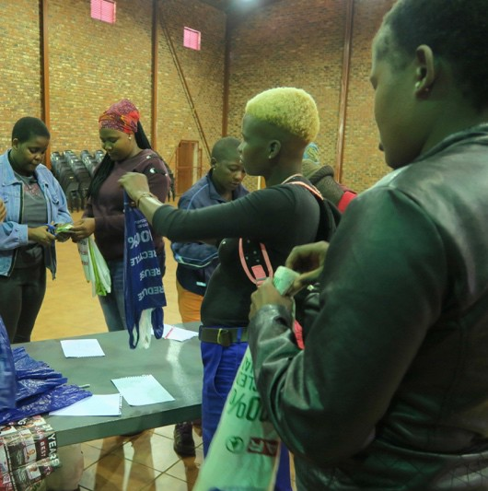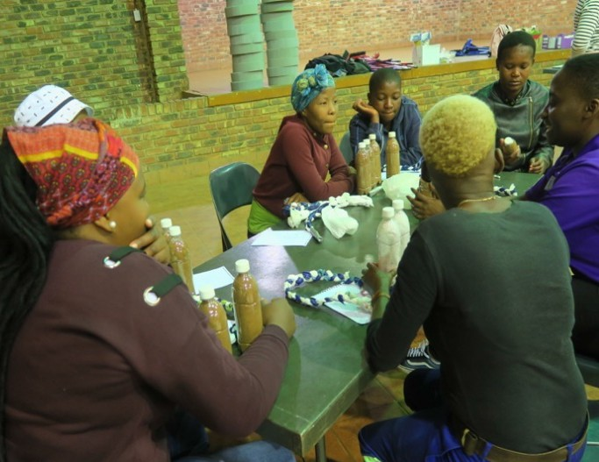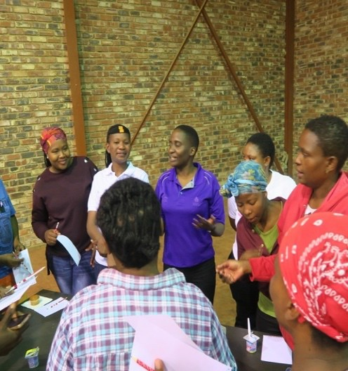Using Photography as Data in Challenging Contexts

Common to challenging contexts is the sense of difference – a lure to the exotic or the different settings in which researchers may find themselves. In these settings, the ordinary things take on a sense of being exotic. The participants may dress differently, eat differently, live in unique settings that lend themselves to photography. Pink (2007) reminds researchers that when we are intimate settings, “the use of visual media and methods creates new ethical and practical dilemmas as the camera [or other recording devices] enters personal domains that might not normally be the object of public scrutiny” (p. 28).
The ethical use of digital documentation – the use of digital media (i.e., camera, video recorder, voice recorder, and photography) to record research interactions might be unethical for several reasons. In some cases, recording participants in a manner in which they could be recognized might jeopardize the participants in some way (i.e., political, social, economic harm) or, it might open up the data to cross-cultural misinterpretation, or might simply present the participants as a curiosity to be looked at as exotic rather than fellow human beings expressing common concerns. Therefore, researchers must attempt, in their desire to seek consent to document the field or individuals in challenging contexts what may be the unintended consequence of showing and sharing various images. As Pink notes “By thinking through the implications of image production and visual representation in this way … [researchers] should be able to evaluate how their images would be invested with different meanings by different political, local and academic discourses (p. 43). Chapter 3 (Pink, 207, p. 65 – 95) offers a more fulsome discussion of the ethical consideration of using photography for research purposes.
Please see Appendix 6 – Tips for Digital Documentation for a more in-depth discussion of this issue

Toolkit for challenging contexts 15

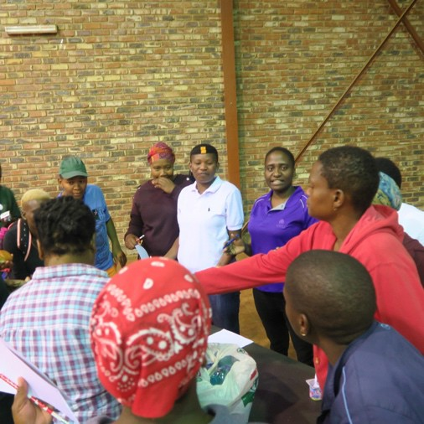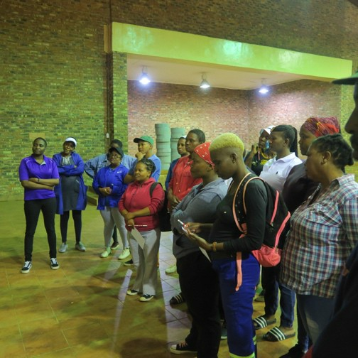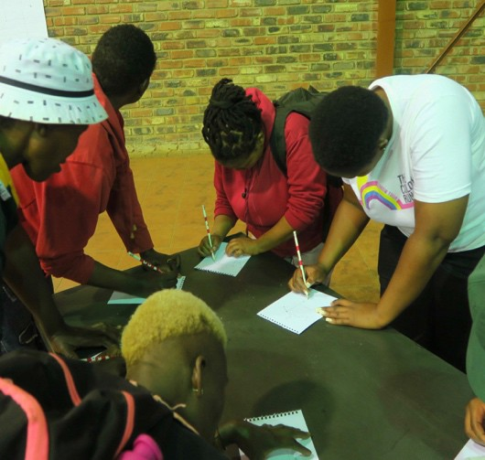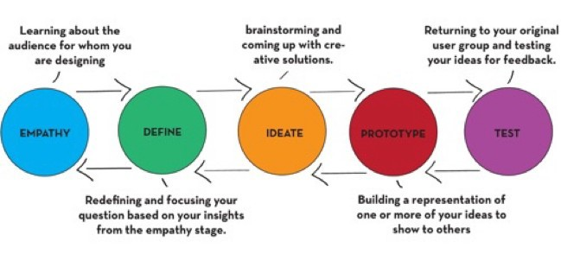2. The Design Thinking Process

Stanford’s five-step Design Thinking process starts with gaining empathy for a challenge or situation through open questioning and interviews with individuals who are dealing directly with the challenge or situation. Design Thinking seeks to gain empathy for a situation by developing an understanding of the concerns, insights, lived experiences, and/or needs of others through interviews/questioning.

Figure 2: The interactive five steps of the Design Thinking process
At the heart of good interviews are great questions – questions that are open, engagingand politely probing. It is through open questions that the person who is being interviewed can share what they are comfortable sharing and become engaged in a conversation that is rich and illuminating to both the interviewer and the interviewee.

2.1 Developing Empathy Starts with Learning to Ask Good Questions

Learning to ask good questions is an outcome of the Design Thinking process. People working in the fields of coaching and leadership (Whitworth, Kimsey-House & Sandahl, 1998; Payne & Hagge, 2009) suggest powerful questions support open discussion and sustained dialogue. Their work is modified and shared in the table below.

Toolkit for challenging contexts 16

Table 1: Examples of questions to ask during the empathy and clarification stages of Design Thinking

Opening Questions  What is your intention?  What impact might this have? What are some other possibilities?  What other ideas do you have about it? | Clarifying Questions  What do you mean? Please tell me more. What concerns you most about this?  What concerns do you still have? What more can you tell me?
Probing Questions  Can you give me an / another example? What have you tried so far?  How did that work? What might be missing? | Options  What are other possible solutions?  What would you like to see happen next? What else could you do?  What other opportunities are there for this?
Action Questions  What are your next steps?  What are you willing to do to refine this? What strengths do you see with this?  What would be helpful in assisting you? | Blocks / Barriers  What got in the way?  What if this doesn’t work, initially? What’s your backup plan?  Are you prepared to take this further?

2.2 Moving to Ideation and Prototyping

The Design Thinking process allows participants to work together to create new ideas, products, ways of working, and research. The fourth step of the Design Thinking process, Prototyping, takes the good thinking arising from the first three steps (empathy, define, ideation) and makes tangible representations of the participants’ thinking. One might argue that it is through the ideation, prototyping and testing steps that Design Thinking comes into its own as a powerful, collaborative methodology.
It is through collective prototyping that participants begin to make their thinking visible (Eisner, 1998). Prototypes can take the forms of posters or sketches, but often, participants are given tools and materials that allow them to make three-dimensional objects. When tools and materials are included, often groups work in a makerspace where they can access shared equipment. Makerspaces do not need to be complete shop environments, and Appendix 2 offers some examples of the various intents and equipment one might consider when developing a mobile or stationary makerspace.

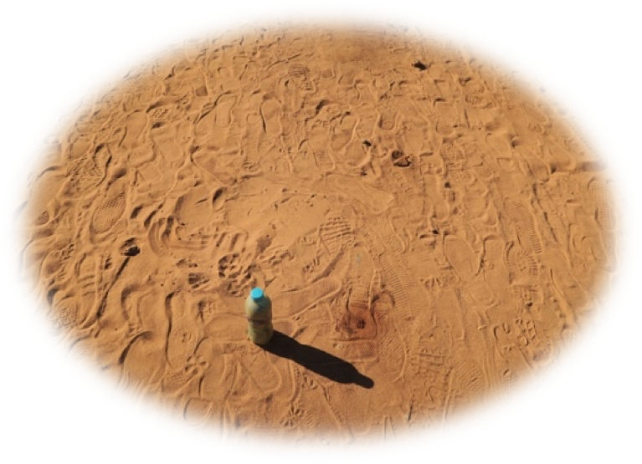

Toolkit for challenging contexts 17

Components of a Good Design Challenge

As stated in Section 1.3, the Design Thinking process is especially valuable to investigate complex or wicked research problems. The following example was offered as a complex or wicked problem prompting our recent research study.
How might understanding the components of a healthy meal assist families in preparing and eating foods that support active, healthy living? Further, what barriers do families in extreme poverty face in attempting to prepare and consume meals that support active, healthy living?
The Innovative Learning Centre (ILC) at the University of British Columbia has refined its Design Challenge structure to incorporate five components. The ILC has learned that each of the components provides enough structure to create a more level and inclusive starting point for research participants. The ILC also recognizes that Design Challenges need to be open enough to invite multiple perspectives, insights and solutions while structured enough to provide support and initial direction. The Design Challenge bridges personal experience with existing situation (i.e., policy, practices, research, etc.).
Crafting a design challenge is the same whether you start with a complex or wicked problem or a research question(s). Each component of the structure is essential and interrelated.
It is not necessary to start writing the components in the order in which they will ultimately appear in the design challenge. Experience suggests as you write each component, the other components will need to be modified and edited to reflect changes in information or intent.
The ILC design challenge format consists of the following five components:

  - Overview Statement - provides the background for the challenge
  - Design Rationale - provides the authentic context for why the challenge is important and connects the actual challenge to the participants by situating it within their context and lived experiences
  - Problem Scenario - invites participants into the challenge and explains their group’s role and reason for involvement in addressing the challenge.
  - Success Determinants - provides the criteria for how the information that is shared and the solutions that will surface, be assessed / or analyzed during the groupsharing
  - Parameters – provides the rules and limitations groups have to follow or adhere to and they explain the opportunities, constraints, rules, requirements to use the materials, resources, tools available during the Design Thinking process.

Toolkit for challenging contexts 18

Tips on Crafting Design Challenges as Provocations for Research Overview
    - Typically, it is very short and subtlety positions the challenge within what the participants already know.
    - The introduction makes the challenge real by situating it within current events, history, your community, etc.
    - Depending on the literacy levels and Internet access of the participants, web links can be provided that link the challenge to existing content / resources.

Design Rationale
- In this section, new information / content can be introduced. It provides content essential for participant understanding of the research question(s) or research intervention.

Problem Scenario
  - Everyone loves a good story. Scenarios provide a narrative that helps participants move from merely thinking about concepts in an abstract sense (theoretical knowledge) to feeling about the concepts and applying them in real or concrete applications.
  - It helps participants to shift from passively reading about / thinking about information to doing something with the information.
  - When actively creating their own knowledge about complex things, participants begin to form their own questions, recognizing that learning is not merely about answers, it is about GREAT questions.

Success Determinants
- Design Thinking and making engage participants in a process that tends to lead to a product.
- Tips as to expectations and possibilities are important for reluctant or vulnerable participants who might be unsure as to what is possible. Some times when situations are too open, creatively and good thinking is stymied if participants are afraid of being wrong. Design loves constraint, and the more vulnerable the population, often the less able / willing they may be to take risks.

Parameters
  - They set the ground rules for working within the challenge. For example, this section might tell participants what they have to use or do to create common experience (i.e., participants to have to use something of everything in a group kit that is provided while they have an option to use things in a shared pantry of consumable items). Constraints like this promote divergent, lateral thinking.
  - Participants should be directed to a Safety Station where they can be shown the proper way to use the tools and materials available during the challenge, depending on the tools, materials and resources available. See Appendix 2 – Makerspaces by Maker / Prototype Intentions and Safety Issues.

Toolkit for challenging contexts 19

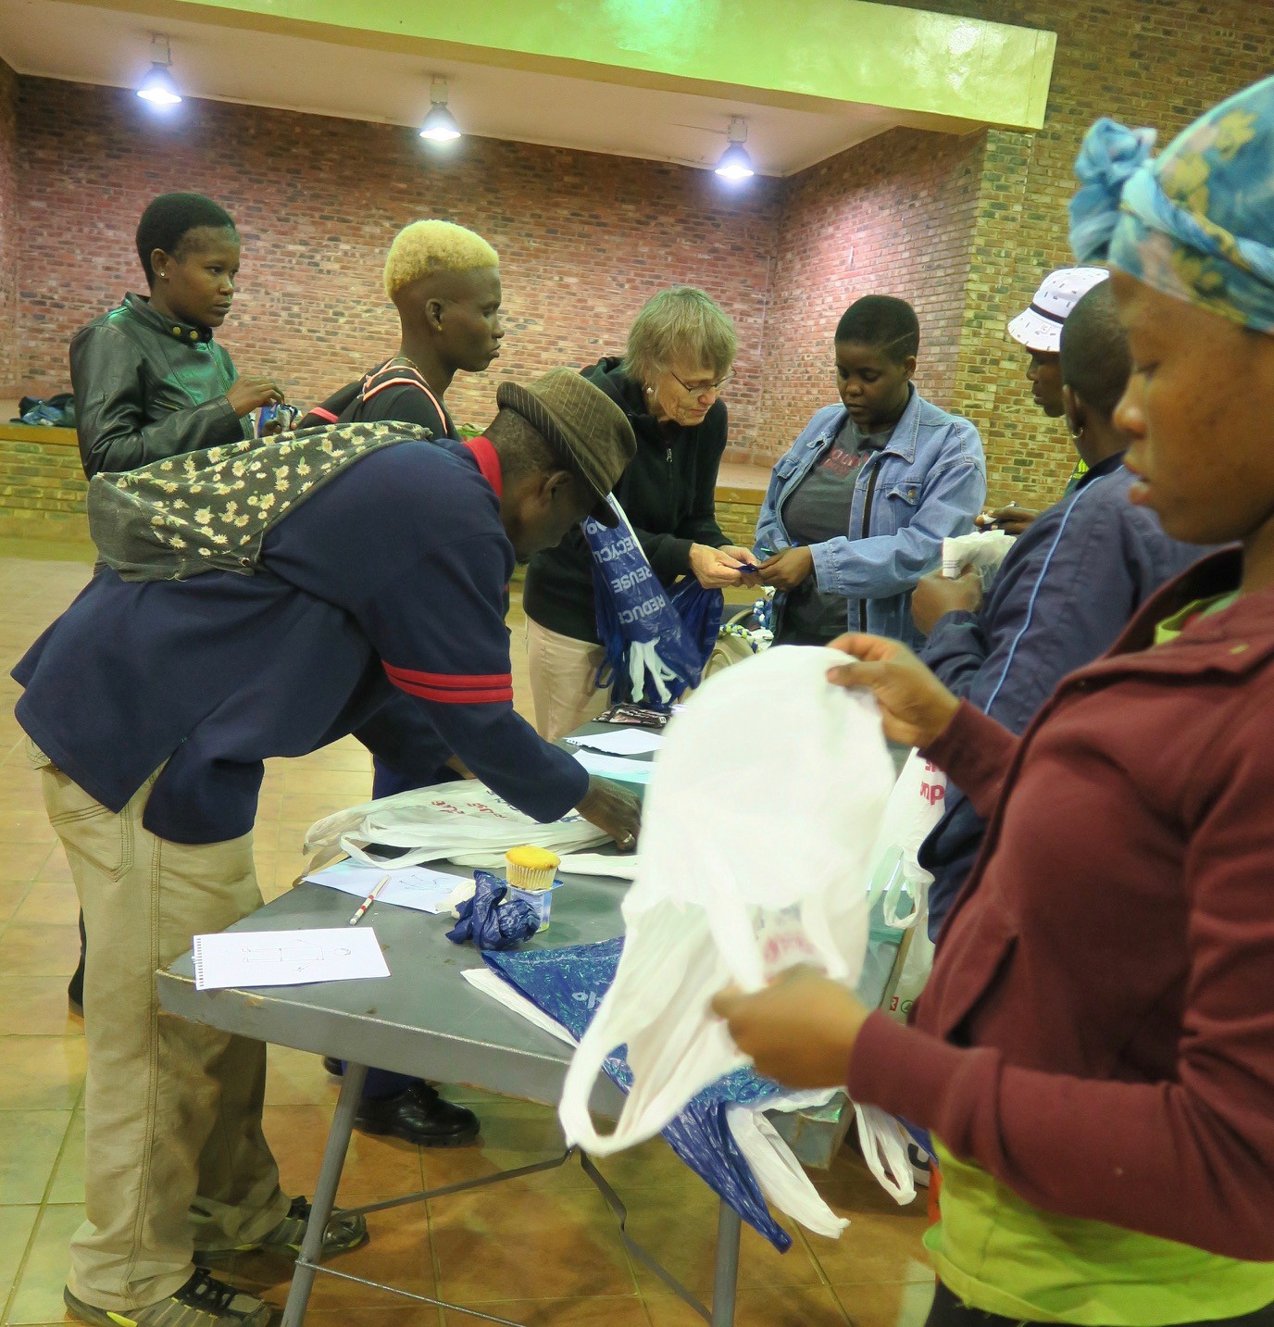3.2 Sample Design Challenge - Sourcing, Preparing and Serving a Healthy Meal

The sample design challenge provided here is based on work done in western Canada. It does not presume to reflect meals / food types found in global challenging contexts, but it does provide a model from which you might create a more appropriate design challenge for your research context.
This sample design challenge builds on the research question shared in Section 3 Components of a Good Design Challenge. As stated in Section 2.4, the Design Thinking process typically starts with a real-world challenge. Using the Design Thinking process, and developing a design challenge as a provocation, researchers can work with their participants to identify the source of the actual challenge by directly engaging with the people experiencing the challenge and the factors that created it. This approach recognizes that solutions to complex problems often rest with those experiencing the problem rather than those bringing generic or pre-determined interventions or solutions. As stated previous, Design Thinking supports problem finding before problem solving.
The complex or wicked problem informing this design challenge is:

How might understanding the components of a healthy meal assist families in preparing and eating foods that support active, healthy living? Further, what barriers do families in extreme poverty face in attempting to prepare and consume meals that support active, healthy living?
Below is an annotated version of a design challenge. The Component Description column offers a description of the purpose of each component in the design challenge.

Toolkit for challenging contexts 20

Table 2: An example of a Design Challenge

Design Challenge: Sourcing, Preparing and Serving a Healthy Meal
Component | Component Description | Designing A Healthy Lunch Experience
Overview | Introduction to the challenge to provide an authentic learning context or situation. | Making our own meals regularly saves money and helps us to eat healthier. But like other healthy things (e.g. exercise, personal wellness, time management, etc.), we often lose our  way and forget to make the time it takes to do what is best for us. Sometimes we forget what a healthy meal even looks like!
Design Rationale | Short explanation of why the challenge is, in fact, a challenge worth addressing and links participants’ prior learning while also providing links to new information.  Resources and sources to guide initial inquiry work can be positioned here. | In a busy world of life balance, work, and the ever increasing cost of good food, we need to pause and consider  what might be a healthy and sustainable meal.  The website (http://lifehacker.com/pack- healthy-hearty-lunches-with-this-six- layer-formul-1752826181) offers an interesting formula to help us to have a balanced, delicious meal experience.  Central to the formula is the notion of a six-component meal which consists of the following elements:  Grains: Anything from rice to quinoa, this will act as the foundation of your meal and be integral to staying full the whole afternoon. Obviously optional if you’re watching your carbs.  Seasonal vegetable: You can throw in more than one veggie, whichever ones you happen to have on hand or is fresh in the garden or market.  Leafy greens: Raw or cooked, greens will bulk up your meal, and if you’re cutting out grains or watching your carbs, switch these out as the base of your meal for a fibrous, healthy alternative.

Toolkit for challenging contexts 21

Design Challenge: Sourcing, Preparing and Serving a Healthy Meal
Component | Component Description | Designing A Healthy Lunch Experience
Protein: Tons of ways you can go here, from sliced chicken, cured meats, tofu cubes, beans, or a hard-boiled egg.
Sour/acidic flavour: Lighten things up and pulls your dish together with an acidic dressing, sauce, or even just a squeeze of lemon.
Healthy fats: This is your chance to really customise each day’s meal, from olive oil to avocado to nuts.
Of concern is how to source, prepare and serve good, meals, and keep a balance of how much of each component is necessary for a healthy diet.
Problem Scenario | Paragraph inviting participants into the challenge and explaining the role/reason for their group’s involvement in addressing the problem | Your team has been selected to develop the perfect tool that addresses the problems we face in sourcing, preparing and serving a healthy meal. Currently, many of us grab quick take away meals without considering other ways we might prepare or supplement existing food. Your task is to make a local solution to this problem.
Success Determinants | Usually begins with “Success Will Be Determined By Degree To Which Your  Design Solution:” followed by criteria assessment using suggested characteristics/attributes that constitute a good design solution for the challenge | - Addresses the design challenge  - Addresses an identifiable need  - Uses the provided materials, resources, and tools  - Is a helpful and unique option for those of us considering sourcing, preparing and serving healthy meals.

Toolkit for challenging contexts 22

Design Challenge: Sourcing, Preparing and Serving a Healthy Meal
Component | Component Description | Designing A Healthy Lunch Experience
Parameters | Specific issues, constraints, or limiting factors impacting the participants and should address (i.e., rules, limitations) for the group to negotiate. | - Plan how to use something of every consumable item in the Participant Group Kit provided  - Choose consumable items and materials found in the Shared Pantry to aid in the enhanced development of your group’s prototype  - Use the tools that have been provided at the Shared Tool Station

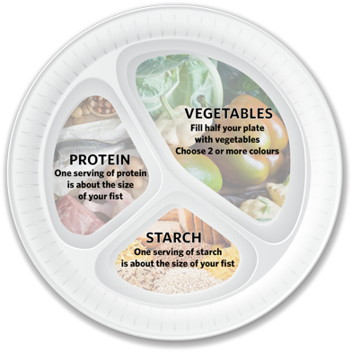A fun solution to the Sourcing, Preparing and Serving a Healthy Meal design challenge is the Fun Food Frisbee which provides users with a tool to help them visualise healthy quantities of various food types. Nutrition research in Canada suggests half of a person’s plate such be filled with vegetables while the other half should be split between healthy starch and protein. The Fun Food Frisbee can also be used as a plate as well as an exercise tool.

A well-crafted design challenge creates rich, multidimensional
/multimodal/multimedia opportunities for participants to demonstrate what they know and how they came to know it in deep and personal ways. It promotes divergent thinking and offers a creative, open and fun way to share information and build new thinking together. For example, the design challenge, Sourcing, Preparing and Serving a Healthy Meal, works well because it positions the process of making in aid of good thinking and deep understanding of the complex problem of why the majority of people do not get adequate nutrition during a day, and it might even begin to address the wicked problem of affordable food, obesity and/or wellness.

Toolkit for challenging contexts 23

4. References
Botha-Ravyse, C. (2017). Need analysis and the development of sustainable physical activity and nutrition intervention tools within a low resourced community. Available upon request from Chrisna.Botha@nwu.ac.za

Bourne, C., Crichton, S., D. (2015). Reflections on service-learning situated in challenging contexts: Lessons learned. In V. Jagla, A. Furco, & J. Strait (Eds.), Advances in service-learning research series, Service-learning pedagogy: How does it measure up? (pp. 61- 70). Service - Learning and Experiential Education SIG of the American Education Research Association.

Crichton, S. (2013, June). Leapfrogging pedagogy: A design approach to transforming learning in challenging contexts. Proceedings of the 8th International Conference on eLearning (ICEL 2012), The Cape Peninsula University of Technology Cape Town, South Africa.

Crichton, S. & Nicols, W. (2017). Taking Making into Classrooms in Challenging Contexts: A Toolkit Fostering Curiosity, Imagination and Active Learning. Retrieved from https://issuu.com/ubcedo/docs/toolkitccresources_english_issuu

Crichton, S. & Carter, D. (2015). Maker Day Toolkit v2. Retrieved from http://innovativelearningcentre.ca/our-space/maker-days

Cross, N. (2001). Designerly ways of knowing: design discipline versus design science. Retrieved from http://oro.open.ac.uk/3281/1/Designerly-_DisciplinevScience.pdf

Dam, R. & Siang, T. (n.d.). Design Thinking: Get a quick overview of the history. Interaction Design Foundation. Retrieved from https://www.interaction- design.org/literature/article/design-thinking-get-a-quick-overview-of-the-history

Doorley, S. & Witthoft, S. (2012). Makerspace: How to set the stage for creative collaboration. Hoboken, NJ: John Wiley & Sons, Inc.

Edmond, C. (May 24, 2019). The UN went to one of the world's richest countries to look at poverty – This is what it found. World Economic Forum. Retrieved from https://www.weforum.org/agenda/2019/05/the-un-went-to-one-of-the-worlds-richest- countries-to-report-on-poverty-this-is-what-it-found/

Eisner, E. (1998). The Kind of Schools We Need: Personal Essays. Portsmouth, NH: Heinemann.

Hammersley, M. & Atkinson, P. (1995). Ethnography: Principles in practice. New York: Routledge.

Hasso Plattner Institute of Design. (2017). d.School. Retrieved from https://dschool.stanford.edu/

Hatch, M. (2014). The Maker Movement Manifesto. New York: McGraw Hill.

Kramer, J. & Kramer, M. (2011). Collective impact. Stanford Social Innovation Review. Retrieved from https://ssir.org/articles/entry/collective_impact.

Toolkit for challenging contexts 24

Moss, S.J. & Cameron, M. (2015, November). Research in Africa is not for sissies. Faculty of Science, Health, Education and Engineering Research Day. University of the Sunshine Coast, Brisbane, Australia.
Nothing About Us Without Us. Retrieved from https://en.wikipedia.org/wiki/ Nothing_About_Us_Without_Us

Payne, D. & Hagge, E. (2009). Tri-namics Power of One, Two, Three: Provocative Questions for Leadership Wisdom. Deberna International. Delta, BC, Canada.
Pink, S. (2007). Doing visual ethnography. London, UK: Sage Publications.

Printable Workout. (n.d.). Retrieved from https://www.pinterest.ca/search/pins/?q=%23workoutlabs&rs=hashtag_pinrep

Revised Bloom’s Taxonomy Process Verbs, Assessments, and Questioning Strategies. (n.d.). Retrieved from https://www.cloud.edu/Assets/PDFs/assessment/revised-blooms-chart.pdf.

Sharma, A. (2016). Participatory design as a research method. Retrieved from https://medium.com/the-making-of-appear-in/participatory-design-as-a-research-method- bc42c01943b1

Spiro, M. (1990). On the strange and the familiar in recent anthropological thought. In J. Stigler, R. Schweder & G. Herdt (Eds.). Cultural psychology: Essays on comparative human development. New York: Cambridge University Press.

The Gift-Giving Project. (2015). Design Resources. Retrieved from https://dschool- old.stanford.edu/groups/designresources/wiki/ed894/the_giftgiving_project.html

United Nations. (n.d.). Sustainable development goals. Retrieved from http://www.un.org/sustainabledevelopment/sustainable-development-goals/

Whitworth, L., Kimsey-House, H. & Sandahl. (1998). Co-Active coaching: Changing business, transforming lives. Boston, MA: Nicholas Brealey Publishing.

Wicked Problems. (n.d.) Interaction Design Foundation. Retrieved from https://www.interaction-design.org/literature/topics/wicked-problems

Woolf, M. (2006). Come and see the poor people: The pursuit of exotica. Frontiers: the interdisciplinary journal of study abroad. Vol. 13, pp. 135 – 146.

Toolkit for challenging contexts 25

Acknowledgement

The researchers want to thank all the participants from the study for their amazing corporation and wonderful solutions for their own wicked problems.
This research is funded by the National Researach Foundation of South Africa. (NRF) Any opinion, finding and conclusion or recommendation expressed in this material are those of the authors, and therefore, the NRF does not accept any.

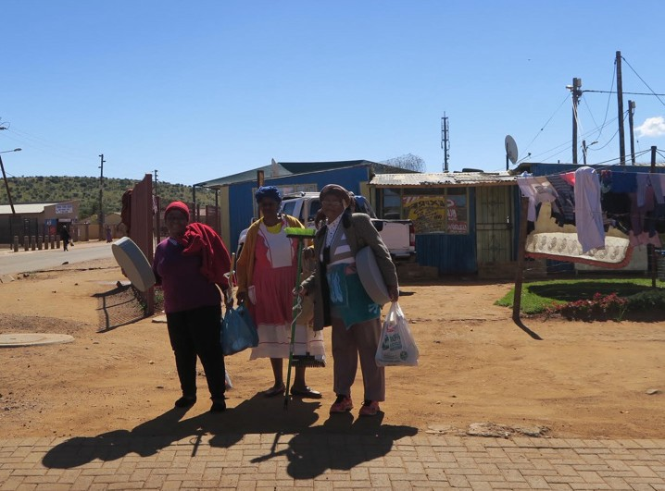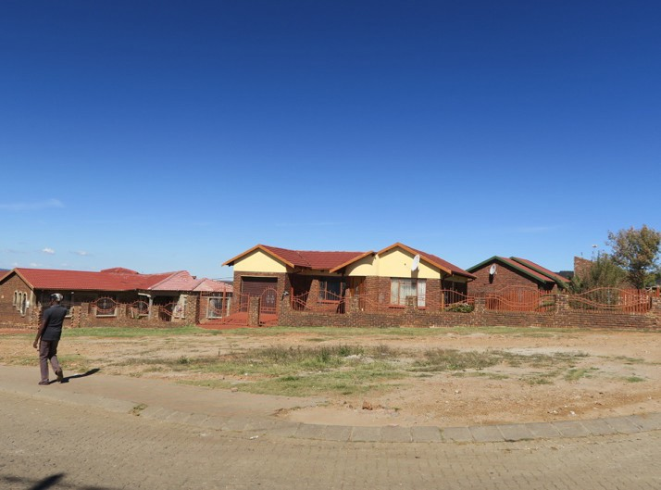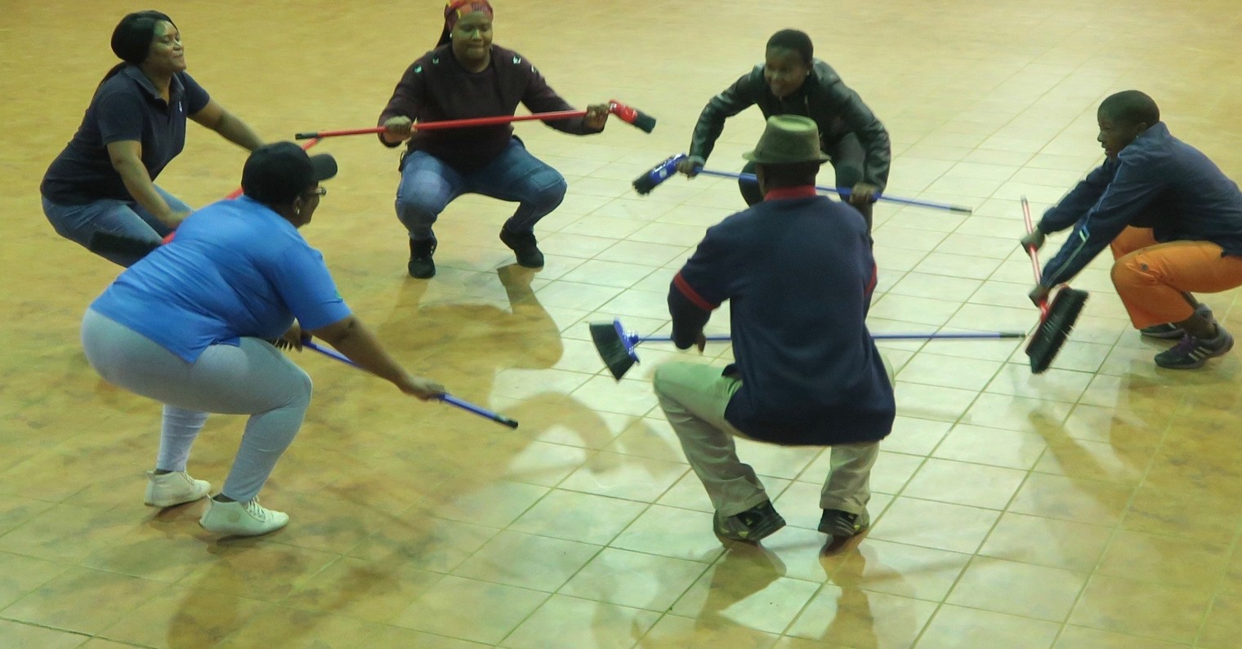

Toolkit for challenging contexts 26

Appendix 1- Tips for Facilitating a Design Thinking Research Session

Appendix 1 assumes you already have a research question that is written in the form of a design challenge (see Section 3 - Components of a Good Design Challenge).

Before You Start the Design Thinking Process
- Prepare the design challenge and obtain materials (A4 paper, pencils, erasers, pencil sharpeners, tools and materials for prototyping)
- Organize your participants into groups of 4.
- Introduce participants to the design challenge. Explain they will be facilitated through a series of timed activities. Assure the participants there may be activities that seem way too long or way too short. Ask everyone to save their questions about the process until after it is completed. For now, tell them to relax and trust the process.
- Give each participant a piece of A4 paper, a sharpened pencil, and an eraser. Ask them to fold the paper into 4 parts and number the parts 1-4. Have extra sheets of paper, pencils and if possible, a pencil sharpener available to the participants.

1. | 2.
3. | 4.

Ask each pair to identify who will be Participant A and who will be Participant B. Before starting, ask Participant A’s to raise their hands. Thank them. Then ask Participant B’s to raise their hands. Thank them. This gives you a quick way to ensure everyone heard your instructions, has made a choice and is ready to start.

Toolkit for challenging contexts 27

Steps for Facilitating a Design Thinking Research Session
Please note, these steps and the sample questions are written to be used with the Design Challenge - Sourcing, Preparing and Serving a Healthy Meal. You will need to write your open questions to match your own Design Challenge. Remember to use the Questions to Open and Sustain Dialogue (see Section 2) to help you craft your questions.
Instructions for Part #1: Empathy - Learning about your partner’s perspectives and knowledge

Guiding Questions: What are the components of a healthy meal? What are the barriers to eating nutritious food and living a more active, nutritious lifestyle?
We suggest allotting 3 minutes for this portion, but you may vary the time as appropriate for your group.
Participant A will have 3 minutes to listen as Participant B responds to the general questions. Participant A will record Participants B’s responses in Part #1. Remind Participants they may need to ask additional powerful, open-ended questions as prompts.
Start timing. Once the time is over, remind Participant As to add any additional notes on their sheet in #1.
Switch roles: Participant B will have 3 minutes to listen to and question Participant A using the same general questions and any additional powerful, open-ended questions as prompts. Remind Participant Bs to record the responses on their sheets in #1.
Start timing. Once the time is over, remind Participant Bs to add any notes on their sheet in #1.

Instructions Part #2: Define Challenges - Learning about your partner’s experiences and contexts
Guiding Question: How might we help families overcome the barriers they face?

Participant A will have 3 minutes to listen and prompt with powerful, open-ended questions as Participant B responds to the question. Participant A records Participant B’s responses in Part #2.
Start timing. Once the time is over, remind Participant As to write additional notes on their sheet in #2.
Switch roles and ask Participant B to listen and prompt with powerful, open-ended questions as Participant A responds to the question. Participant B records Participant A’s responses in Part #2.
Start timing. Once the time is over, remind Participant Bs to write additional notes on their sheet in #2.

Toolkit for challenging contexts 28

Instructions for Part #3: Define Evidence - Asking your partner to describe how their past experiences and learning have informed the challenges they have described.

Guiding Question: How do you know this?

Participant A will have 2 minutes to listen and prompt as Participant B responds to the question.

Start timing. Once the time is over, remind Participant As to write additional notes on their sheet in #3.
Switch roles and ask Participant B to listen and prompt as Participant A responds to the question. Participant B records Participant A’s responses in #3.
Start timing. Once the time is over, remind Participant Bs to write some notes on their sheet in
#3.
Instructions for Part #4: Ideate - Asking your partner to form creative solutions to address their unique challenges

Guiding Question: How might you or your institution address those challenges?
Participant A will have 3 minutes to listen and prompt as Participant B responds to the question.

Start timing. Once the time is over, remind Participant As to write additional notes on their sheet in #4.
Switch roles and ask Participant B to listen and prompt as Participant A responds to the question. Participant B records Participant A’s responses in #3.
Start timing. Once the time is over, remind Participant Bs to write additional notes on their sheet in #4.
Instructions for Part #5: Prototype - Asking participants to work individually to create a prototype of a possible solution

Ask Participants to turn their papers over. Ask the Participants to divide their paper into half numbering one-half #5 and the second half #6

5.
6.

Toolkit for challenging contexts 29

Guiding Question: After reviewing all your notes and reflecting on all the information you and your partner have created, what resources or supports could you develop to support more nutritious eating and active living? How would your resource or supports address at least one of the challenges you and your partner discussed?
Before starting, review the Design Challenge. Remind participants of the definition of a prototype as a representation of one or more ideas to show how you might begin to solve the design challenge.
Participants will be given 5 minutes to answer the guiding questions individually. Ask Participants to describe, using words and / or drawings, how they would begin to develop and design a quality resource that could support active learning and foster growth and intentional mindset in your students.
Start timing.
Instructions for Part #6: Test - Asking another participant to be your critical friend as you describe your resource.

Ask Participants to share their ideas with a Participant in the room that was not their Partner for Parts 1-4. Remind the participants to write down any additional ideas or questions their critical friend surfaces. Ensure that both participants have time to present and receive feedback. Remind everyone to have some notes in #6.
Before starting, remind Participants what it means to be a Critical Friend.
  - Ask open questions
  - Give constructive feedback
  - Offer supportive ideas
  - Use “and” rather than “but” when offering feedback

If time allows, have the original partners meet to go over their solutions and feedback.

Toolkit for challenging contexts 30

Appendix 2 - Makerspaces by Maker / Prototype Intentions and Safety Issues

The introduction of makerspaces into some schools, universities and community settings has added pressure for many site administrators and managers. Groups have raced to purchase what they believe is essential equipment – 3d printers and extensive CNC machines and circuity to support robotics and coding, etc. Equipment such as this is valuable, and it adds additional elements of supervision, safety and maintenance and facilitator support to a makerspace.
Adding a makerspace to sites does not necessarily mean you must add a complete shop environment. It does, however, require organizers to consider the intended use of the space and the intention of the making that will take place there. The ILC has consulted on the design and equipping of makerspaces from the most sophisticated one located at UBC Okanagan to the simplest one that is mobile and used in a school in a refugee camp situation in northern Uganda. The first step is considering the intended use of the makerspace. The following learning offer a guide for the equipment and materials that might be found in a range of makerspace environments. Appendix 4 – Tips for Materials and Resources by Maker Intentions offers suggestions for items that could be purchased or found to equipment makerspaces based on prototyping intentions.
Common to most effective makerspaces is a collaborative space where people can come together to engage in Design Thinking, prototype ideas and share their ideas in a supportive, welcoming environment.
The book Makespace: How to Set the Stage for Creative Collaboration by Scott Doorley and Scott Witthoft documents the wonderfully inviting and simple collaborative spaces developed by colleagues at Stanford’s d.School. The book provides tips, schematic drawings and suggestions for making collaborative spaces and utilizing simple materials and resources. Using wall spaces as drawing spaces, sketching with washable crayons and chalk helps to make thinking visible and shared. The experiences from the ILC tells us that visuals, open spaces, and writeable surfaces help to encourage openness and collaboration (Doorley & Witthoft, 2012). Regardless of the maker intent, the process of making starts with Design Thinking and the actual making is done during the prototype step of the process. Making without design is more hobby than process. While there is anything wrong with making as a recreational activity, stand-alone making does not honour the integrity and intent of the Design Thinking process. For more on the design of makerspaces, please consult Makespace (Doorley & Witthoft, 2012).

Toolkit for challenging contexts 31

Complex to Simple Expensive to Inexpensive� Advanced to Introductory | Maker / Prototype Intention | Description | Basic Tools | Basic Materials
 | Design and Basic Making | Introduction of Design Thinking and the making of simple, tangible items to illustrate design ideas in 3d | Hand tools, including glue guns, rulers, knives, scissors, etc. | Cardboard, recycling, simple found or purchased items (buttons, sticks, fabric, etc.)
 | Design and Simple Prototyping | Introduction and continued use of Design Thinking and more elaborate prototyping of ideas to scale | Hand tools and simple power tools such as Dremel tools, electric drills, etc. | Cardboard,  recycling, simple found or purchased items with additional of Styrofoam, plastic pipe and fittings and other materials that can easily cut and fastened
 | Design and Fabrication | Use of Design Thinking and introduction of fabrication to create working prototypes at scale | Hand and power tools with option for 3d printers, CNC machines, etc. | Use of authentic materials
 | Design, Prototyping, Circuitry and Coding | Use of Design Thinking with the addition of coding and circuitry to add functionality to prototypes | Hand and power tools, soldering irons, circuits, breadboards, etc. | Use of authentic materials, including Arduino, circuits, robotics, etc.

Safety is also a concern in makerspaces. Typically, makerspaces are facilitated environments with people available who know how to use the various pieces of equipment and ensure that there are adequate resources and materials for participants to use. The following is a suggestion for safety considerations in relation to makerspace intentions.

Toolkit for challenging contexts 32

Complex to Simple Expensive to Inexpensive Advanced to Introductory | Maker / Prototype Intention | Basic Tool | Initial Safety Concerns
 | Design and Basic Making | Hand tools, including glue guns, rulers, knives, scissors, etc.) | - Emphasis is on accurate measuring and safe cutting and careful assembly.  - Use of ruler both for measuring and as a straight edge to cut against  - Safe ways to walk holding sharp objects  - Safe ways to use hot elements like glue guns and hot glue  - Ways to help your group members – where  to stand, how to hold things, use of tools with and among other people
 | Design and Simple Prototyping | Hand tools and simple power tools such as Dremel tools, power drills, etc. | - Focus is on accurate measuring and safe cutting and careful assembly; emphasis is on selection of the appropriate tool for the task.  - See bulleted list above  - Use of v blocks and clamps to hold materials prior to drilling, cutting or shaping  - Use of eye and ear protection for user and those immediately around them  - Use of gloves – where appropriate  - Use of drill bits and Demel attachments  - Use of extension cords, cables, power bars, etc.  - Ways to help your group members – where to stand, how to hold things, use of tools with and among other people
 | Design and Fabrication | Hand and power tools with option for 3d printers, CNC  machines, etc. | - Focus is on accurate measuring and safe cutting and careful assembly; emphasis is on selection of the appropriate tool for the task.  - See bulleted lists above  - See safety concerns specified by specific tool to be used  - Address issues of ventilation and air quality  - Ways to help your group members – where to stand, how to hold things, use of tools with and among other people
 | Design, Prototyping Circuritry and Coding | Hand and power tools, soldering irons, circuits, | - Focus is on accurate measuring, safe cutting and careful assembly; selection of the appropriate tool for the task; emphasis is on the addition of functionality to the design through the  inclusion of circuits and coding

Toolkit for challenging contexts 33

 |  | breadboards, etc. | - See bulleted lists above  - Address issues of ventilation and air quality, especially when soldering

Toolkit for challenging contexts 34

Appendix 3 – Tips for Making and Fastening

This appendix offers a starting place for considering tips, tricks, resources and materials. This is an exhaustive list, and part of the fun is finding and sharing new ideas. But, everyone needs a little help to get started! Here’s a starting gift and sites like Exploratorium (http://www.exploratorium.edu/), Instructables (http://www.instructables.com/), Smithsonian LearnLab (http://www.smithsonianeducation.org/educators/index.html), etc. are inspiring labyrinths of wonderful ideas where good makerspace facilitators will find wonderful ideas and
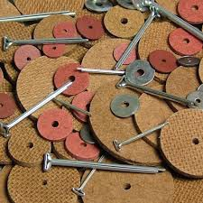disappear for hours of exploration!

Tips for Structures and Stability
Cotter pins, washers and disks for articulate joints
When you want to hold material together (i.e., cardboard, fabric, plastic, etc.) and still be able to move the pieces similar to the should joint of an articulated toy bear, cotter pins, washer and rigid disks are the answer. Please watch this video to see how this can be done.
The example in the video is the creation of a bear with moveable arms, but you can adapt this tip for use with plastic pipe to make prototype crane and a million other things.
https://www.youtube.com/watch?v=9rW004vw88w

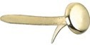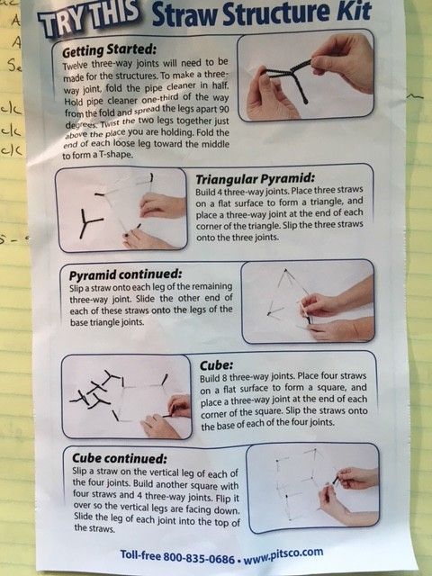Substituting brads/fasteners for cotter pins
If the material you are fastening is light weight (i.e., thin cardboard or
heavy paper), simple brass-plated fasteners or brads will work. However, they lack the structural integrity of cotter pins and washers and will eventually wear
Pipe cleaners and straws as joinery
You can make use of a single pipe cleaner, folded three- ways, to make a joint capable of connecting three straws and creating a stable corner.
PITSCO’s Straw Structures Teacher’s Guide, offers instruction, resources, puzzles, lesson activities

http://www.pitsco.com/Straw_Structures_Teachers_Guide.

Toolkit for challenging contexts 35

Cardboard Fastener Techniques
Cardboard can be shaped into a variety of fasteners to provide structural integrity to project designs.

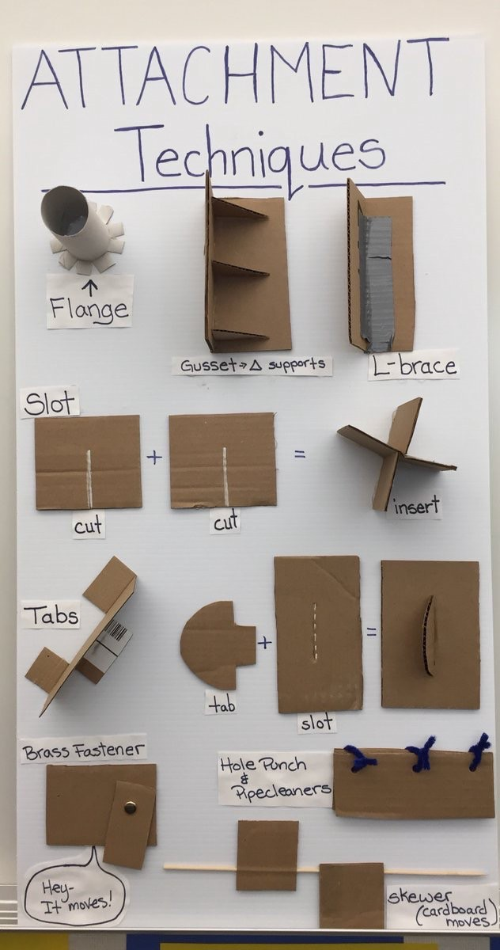

Toolkit for challenging contexts 36

Appendix 4 – Tips for Materials and Resources by Maker Intentions

Participant Group Kits and Shared Pantry Contents for Prototyping as Part of the Design Thinking Process
Commend these components to support the design and prototyping process and to ensure participants are supported in making their ideas provoked from the design challenges tangible and shareable. These materials are only suggestions and should be relatively affordable and accessible. Where possible, try to use as many recycled materials as you can.
The Participant Group Kit is used as a disrupter! Design Thinking is fundamentally about divergent, lateral thinking that disrupts designers from rushing to solutions and to engage in human-centred thinking that enables problem finding. Once participants have completed their initial Design Thinking work and before they begin prototyping, we suggest providing them with a Participant Group Kit. You will note that the Design Challenges format offered in Section
3.1 states in the Parameter that the team “Plan how to use something of everyday consumable item in the Participant Group Kit provided. We have found that adding this final disrupter into the design process is important. Once again, groups are required to consider their design, ideating and iterating ways in which to use the new resources for best advantage and functionality.
We offer the following suggestions for Participant Group Kits by design intention. Please note, these are only suggestions and should be modified by availability to materials, budget consideration, recycling/reuse options, culture, location, etc. We also offer a suggestion for tools to support a mobile maker configuration for classrooms.

Suggested Participant Group Kits by Making / Prototyping Intention
Making / Prototyping Intention | Description | Participant Group Kits  - 1 kit for each group of 4 participants  - Quantities of each consumable item are less important as students do not have to use all the items and additional items are available from the Shared Pantry
Design and Basic making | Introduction of Design Thinking and making simple, tangible items to illustrate design | - Lunch size brown paper bag to hold content  - Small piece of Hook and Loop Stick- On Strips (common commercial name: Velcro)  - 1-3 meters of jute or string

Toolkit for challenging contexts 37

Design and Simple Prototyping | Introduction and continued use of Design Thinking and more elaborate prototyping of ideas to scale | - Lunch size brown paper bag to hold content  - Small piece of Hook and Loop Stick-On Strips (common commercial name: Velcro)  - 1-3 meters of jute or string  - Straws  - Misc coloured paper  - Foam pieces / or small piece foam core  - Toothpicks  - Bamboo skewers  - Modelling clay  - Kitchen garbage size plastic bag  - Marbles  - Springs – small  - Tie Wire (1 meter)  - Wood pieces - Tongue depressor type  - Coloured wooden pieces – craft items
Design and Fabrication | Use of Design Thinking and introduction of fabrication to create working prototypes at scale ideas in 3d | Same as for Design and Simple Prototyping Above  - Wire  - Straws  - Misc coloured paper  - Foam pieces / or small piece foam core  - Toothpicks  - Bamboo skewers Modeling clay

Toolkit for challenging contexts 38

Suggested Shared Pantry by Making / Prototyping Intention
Making / Prototyping Intention | Description | Pantry Items
Design and Basic Making | Introduction of Design Thinking and the making of simple, tangible items to illustrate design ideas in 3d | - Cardboard boxes (recycling or from grocery/appliance stores)  - Plastic shopping bags  - Cardboard pieces  - Egg cartons – paper and foam  - Magnets (pieces and sheets)  - Modelling clay  - Paper scraps and sheets  - Styrofoam (recycling)  - Tape – duct  - Tape – electrical, coloured and clear  - Fabric  - Misc found and fun items
Design and Simple Prototyping | Introduction and continued use of Design Thinking and more elaborate prototyping of ideas to scale | - Cardboard boxes (recycling or from big box stores)  - Cardboard pieces  - Egg cartons – paper and foam  - Magnets (pieces and sheets)  - Modelling clay  - Paper scraps and sheets  - Styrofoam (recycling)  - Tape – duct  - Tape – electrical, coloured, clear  - Fabric  - Misc found and fun items  - Irrigation pipe with appropriate fittings  - Doweling – misc sizes
Design and Fabrication | Use of Design Thinking and introduction of fabrication to create working prototypes at scale | Same as for Design and Simple Prototyping above  - Depending on access to tools, consider dimensional lumber and scrap wood  - Structural materials – pieces of acrylic sheeting, etc.
Design, Prototyping, Circuitry and Coding | Use of Design Thinking with the addition of coding and circuitry to add functionality to prototypes | Same as for Design and Simple Prototyping above  Refer to Coding & Microcontrollers in Design for Ardruino and simple circuit ideas  (https://issuu.com/ubcedo/docs/diy_guidebook)  Also refer to the Ardruino site (http:// playground.arduino.cc/Projects/Ideas) for suggested activities and resources

Toolkit for challenging contexts 39

Suggested Shared Tool Station By Making / Prototyping Intention
Making / Prototyping Intention | Description | Pantry Items  Ensure there are adequate power bars available to power tools as required
Design and Basic Making | Introduction of Design Thinking and the making of simple, tangible items to illustrate design ideas in 3d | - Box cutters (utility knives)  - Glue guns(mini craft size) or heavy purpose glue  - Replacement mini glue sticks  - Pencils with erasers  - Felt markers  - Pliers  - Metal rulers  - Scissors  - Measuring tape
Design and Simple Prototyping | Introduction and continued use of Design Thinking and more elaborate prototyping of ideas to scale | Same as for Design and Simple Prototyping  - Drywall straight edge  - Handheld Dremel tool  - Dremel tool  - Dremel Rotary Tool Work Station  - Dremel Flex Shaft Attachment  - Dremel tool accessories (bits, etc.)  - Hand saw  - Small drill – battery powered  - Wooden V blocks with clamps (turns almost all flat surfaces into a vice for holding items to be cut or drilled)
Design and Fabrication | Use of DT introduction of fabrication to create working prototypes at scale | Same as for Design and Simple Prototyping  Depending on materials and technical  support, consider chop saw and other power tools
Design, prototyping, circuitry and coding | Use of DT with the addition of coding and circuitry to add functionality | Same as for Design and Simple Prototyping  - Soldering iron  - Flux  - Sphero  - littleBits  - Lily pad Ardruino (fabric and sewing supplies

Toolkit for challenging contexts 40

Mobile Maker Kit (Suitable for 40 participants)
Kit Items (alphabetical) | Quantity | Notes
Rolling suitcase or toolbox | 1 | This container needs to hold all the kit items and able to be secured. Mobile toolboxes often have fasteners that allow for locks and a chain to secure them when they are not used.
Clamps, Rachet | 2 | 6” – 150 mm Quick Ratcheting Bar Clamp — Used to make cutting safer; use with a v block to hold round material
Clamps, Ratchet | 3 | Used to make cutting safer; use with a v block to hold round material
Dremmel Kit (optional, depending on budget & site) | 1 | Dremel or Dremel-like tools offer numerous attachments for cutting, drilling, sanding options. The tool is small, easy to use, and accessible for reluctant tool users
Drill bits | 1 Kit | Various sizes
Drill, Cordless Electric (optional, depending on budget & site) | 1 | Basic battery powered, lightweight drill
First Aid Kit | 1 | Basic Kit
Glue Gun, Mini | 4 | Lower heat and longer to heat up — Used for tongue depressors, etc.
Mini Glue sticks | 1 pkg | Refills
Glue Gun, Rapid heat | 1 | Heats faster and hotter than mini glue guns — Used for Doweling, Plastic, Metal
Glue Gun, Rapid heat sticks | 1  package | Refills
Hammer | 1
Pliers | 4 | Preferred: Needle Nose with wire cutter
Power Bar | 1 | Preferably 6 foot reach and at least 6 plug-ins
Rulers, 12” | 5 | Recommend: Steel rulers to use with utility box cutters
Saw, Fine-tooth hand | 3 | Folding pruning saw also works well

Toolkit for challenging contexts 41

Mobile Maker Kit (Suitable for 40 participants)
Kit Items (alphabetical) | Quantity | Notes
Saw, Hack | 2 | Easier to cut with than wood saws
Scissors | 5 | Preferred: various sizes/functions
Squares, Quick Angle | 5 | Good for complex mathematics measuring and angle cuts
Tape Measure | 5 | 12 foot is adequate
Utility box cutters | 5 | Some come with refillable blades in the handle

Toolkit for challenging contexts 42

Appendix 5 – Sample Participant Consent Form

HREC Stamp

INFORMED CONSENT DOCUMENTATION FOR COMMUNITY MEMBERS WITH NCDs RECEIVING SUPPORT FROM COMMUNITY HEALTH CARE WORKERS
TITLE OF THE RESEARCH STUDY: Needs analysis to develop a co-designed technology-based lifestyle intervention within a low-resourced community

ETHICS REFERENCE NUMBERS: NWU-00059-18-S1
PRINCIPAL INVESTIGATOR: Dr Chrisna Botha-Ravyse ADDRESS: Papinsalmenkatu 16, Turku, Finland CONTACT NUMBER: +358 41 488 0794
You are invited to take part in a research study that is funded by the National Research Foundation (NRF). Please take some time to read the information presented here, which will explain the details of this study. Please ask the researcher or person explaining the research if you have any questions about any part of this study that you do not fully understand. It is very important that you clearly understand what this research is about and how you might be involved. Also, your participation is entirely voluntary and you are free to say “no” to participate. If you say “no”, it will not affect you negatively in any way. You are also free to withdraw from the study at any point, even if you do agree to take part now.
This study has been approved by the Health Research Ethics Committee of the Faculty of Health Sciences of the North-West University (NWU NWU-00059-18-S1) and will be conducted according to the ethical guidelines and principles of Ethics in Health Research: Principles, Processes and Structures (DoH, 2015) and other international ethical guidelines applicable to this study. The research ethics committee members or other relevant people may inspect the research records.

Toolkit for challenging contexts 43

What is this research study all about?
- This study is being done so that we can understand how much you know about healthy eating and exercise to better manage your risk factors against healthy living, or to prevent any such risk factors.
- We would like to develop an application for mobile telephones that will help to improve exercise participation and healthy eating. To help us make the application we will ask some questions about how much you use technology.
- This study will be done in Ikageng at the health clinics where you go for your monthly visits (Lesego Clinic and Steve Tshwete clinic) and will be done by experienced health researchers trained in Design Thinking, exercise and healthy eating. We aim to include 225-230 community members in this study.

Why have you been invited to participate?
- You have been invited to participate because: you are between the ages of 18-65 and are able to participate in physical exercise. You may or not be currently diagnosed with risk factors for NCD (diabetes, coronary artery disease, osteoporosis, cancer, hypertension). These risk factors include tobacco use, alcohol consumption, being overweight, physical inactivity, high blood pressure, and high cholesterol. You are voluntarily taking part in the research.
- You will unfortunately, not be able to take part in this research if you have an uncontrolled medical condition such as hypertension or diabetes, together with any absolute contra-indication for physical exercise as indicated in the American College of Sports Medicine and neuromuscular conditions that prevent physical activity (ACSM, 2013).

What will be expected of you?
- You will be requested to fill in questionnaires about how often you use cell phones and ifyou get visits from the health care workers. We will also ask questions about healthy eating.
- You will be asked to answer some questions on your willingness to use mobile technology to help you in the treatment of your condition.
- You will be expected to attend a focus group discussion (in a group of 6 to 8 participants), during which we will talk about your opinion on barriers to regular exercise. The researcher will ask questions to start the conversation and then guide the discussion. This is an open discussion, where the people taking part can also bring their own questions to understand more about exercise and healthy eating.
- The focus group discussions will be voice recorded. There will also be a scribe and atranslator present during the focus group discussions.
- You will be asked if you would like to participate in a maker day, where we will make use of creative ideas from you to guide us and help us find a solution to any problems about exercise and healthy eating you may have.

Toolkit for challenging contexts 44

Will you gain anything from taking part in this research?

- By helping to create a sustainable exercise tool, your awareness of the benefits of physical activity will increase and you will have greater knowledge about nutrition. This may help to lower your risk for activity-related diseases and poor nutrition. You will also help the rest of your community (and other communities) when the application is ready to be used by everyone. Your participation will add to the health goals of the country.

Are there risks involved in you taking part in this research and what will be done to prevent them?
- Questionnaires:
You may feel vulnerable when asked about your current physical activity participation and knowledge of the food based dietary guidelines or FBDG. In order to minimise this discomfort and vulnerability, questionnaires will be done in a private room where you can complete the questionnaires without being influenced or intimidated by anyone.
- Focus group discussions:
During focus groups, only partial confidentiality can be provided. We will try to protect you by giving you a false name during the recording and transcription of the focus group discussion. Focus group participants will be asked to keep the discussion confidential, however, we cannot guarantee that all participants will not tell others what happened in the focus groups.
- Maker day activity
The maker day can be a long day, but it will be done in an informal way with no strict structures so you can take breaks as often you want or need. Water will be available at all times and you will receive refreshments for two tea times (one morning and one afternoon). Lunch will also be served.

How will we protect your confidentiality and who will see our findings?
- Your privacy will be respected by the researchers. The researcher will use letters of the alphabet as name codes for everyone to protect their identity. Only the researchers and their co- workers will be present during the focus group discussions and they will all sign a confidentiality agreement.
- When filling in questionnaires, you will be in a private place and no one, except the fieldworkers that help with the study, will know your answers.
- Anonymity of your contribution will be protected by replacing your name with a number. Your results will be kept confidential by ensuring no one, except the researchers, have access to them. Only the researchers and person doing the statistics will be allowed to see your contribution. Paper copies of the findings will be kept in locked cupboards in the researcher’s office. Electronic data it will be password protected (as soon as data has been transcribed, it will be deleted from the recorders). Data will be stored for 7 years.

What will happen with the findings or samples?
- The findings of this study will only be used for this study to inform the design of a solution as discussed with you during the Maker Day.

Toolkit for challenging contexts 45

How will you know about the results of this research?

We will give you the results of this research when we show you a prototype of what we think might work as a solution.
- You will be informed of any new relevant findings by Prof Hanlie Moss in an information session.

Will you be paid to take part in this study and are there any costs for you?
- This study is funded by National Research Foundation (Thuthuka award).
- You will not be paid to take part in the study.
- Travel expenses will be paid for travel to the clinic.
- Refreshments and a meal will be served on the days of data collection and on the Maker Day.
- There will be no costs for you, if you take part in this study.
Ø You will receive a gift voucher to say thank you for your time.

Is there anything else that you should know or do?
- You can contact Prof Hanlie Moss at (018) 299-1802 or Dr Chrisna Botha-Ravyse at chrisna.botha@nwu.ac.za if you have any further questions or have any problems.
- You can also contact the Health Research Ethics Committee via Mrs Carolien van Zyl at 018 299 1206 or carolien.vanzyl@nwu.ac.za if you have any concerns that were not answered about the research, or if you have complaints about the research.
- You will receive a copy of this information and the consent form for your own purposes.

Toolkit for challenging contexts 46

Declaration by participant

By signing below, I …………………………………..…………. agree to take part in the research study titled: Needs analysis with the aim of developing a technology based lifestyle intervention within a low-resourced community
I declare that:
- I have read this information / it was explained to me by a trusted person in a language in which I am fluent and comfortable.
- The research was clearly explained to me.
- I have had a chance to ask questions to both the person getting the consent from me, as well as the researcher and all my questions were answered.
- I understand that taking part in this study is voluntary and I have not been pressurised to take part.
- I may choose to leave the study at any time and will not be treated in a negative way if I do so.
- I may be asked to leave the study before it has finished, if the researcher feels it is in my best interest, or if I do not follow the study plan as agreed.

Signed at (place) ......................…........…………….. on (date) 20....

Signature of participant Signature of witness Declaration by person obtaining consent
I (name) ……………………………………………..……… declare that:
- I clearly and in detail explained the information in this document to
………………………………………………….
- I did / did not use an interpreter.
- I encouraged him/her to ask questions and took adequate time to answer them.
- I am satisfied that he/she adequately understands all aspects of the research, as discussed above.
- I gave him/her time to discuss it with others if he/she wished to do so.

Toolkit for challenging contexts 47

Signed at (place) ......................…........…………….. on (date) 20....

Signature of person obtaining consent Declaration by researcher
I (name) ……………………………………………..……… declare that:
- I had the information in this document explained by ……………………………………, whom I trained for this purpose.
- An interpreter was / was not used.
- Participants were encouraged to ask questions and enough time was spent in answering them /or I was available should he/she want to ask any further questions.
- The informed consent was obtained by an independent person.
- I am satisfied that he/she adequately understands all aspects of the research, as described above.
- I am satisfied that he/she had time to discuss it with others if he/she wished to do so.

Signed at (place) ......................…........…………….. on (date) 20....

Signature of researcher

Toolkit for challenging contexts 48

Appendix 6 – Eleven Tips for Digital Documentation

In the research context shared in this toolkit, we used digital photography – based still and video – to record the process of our data collection, provide evidence of the impact of our interventions, and create a record of the participants’ engagement in the process. The ability to digitally document your research context depends on the willingness of your participants and the ethical consent you obtain from both your university / granting agency and the research collaborators/partners.

A question that typically arises for researchers preparing to use digital documentation in their research is, “If digital documentation is important, how do I know what to take and when to take it?” We suggest the answer rests in experience, patience, and opportunity. Further, we would never minimise the importance of Louis Pasteur’s statement ―Chance favours the prepared!

We offer these tips as a way of improving your chances to document your research context. We acknowledge there are entire texts and workshops devoted to this topic, but the tips offered here are those we have generated through our experiences and interactions with numerous participants in a range of challenging contexts – both local and global to us.

Tip #1 – Do Your Homework

Read before you go into your challenging context, try to understand the culture, background, roots and sensitivities of the people and places you will visit. Consider what digital documentation will add to your research and how you will use it?
- Are you only using your photos for your data set and therefore no one other the participants and research team will see them?
- Are you planning to use the pictures as illustration/evidence in your publications/ presentations?
- Are there other uses/considerations about the photos that you need to think about?

Tip #2 – Look at Photos from the Pros
Studying photographs taken by professionals can help to train your eye. Look at a photograph and try to see beyond the flash and glamour of the image and determine the why and how of the picture. What was the photographer attempting to capture; what is the story? Then, study the actual process of the picture—what is the composition, the lighting, etc.—basically the elements discussed in Suggestions #4 - #11.
You might enjoy exploring the pictures in the following online collections:
  - http://photography.nationalgeographic.com

Toolkit for challenging contexts 49

  - https://widerimage.reuters.com/
  - https://www.icp.org/

Tip #3 – It’s All About the Story and the Research Questions
Great photographs are prompts for great stories. Pictures can cause researchers and viewers to reflect on place, time, and situation. They invite the viewer right back into the scene and challenge assumptions and prompt further inquiry. The adage ―a picture is worth a thousand words resonate today because it still holds true—and those thousand words are the basis of a good storyline and a way to share a research context.
Every picture needs a good storyline—something that prompts the viewer to ask more, want to know more, to care about what happens next or what happened before. Remember, most good stories have a beginning, middle and end, so you need to think about where in a sequence of data collection does your photograph sit? And, whether or not you need a sequence or series of pictures to tell the tale. The majority of ―good photographs reflect experiences that prompt rich stories.

Tip #4 – Think Composition

Like a good story, a good picture has a clear message: something simple and focused that invites discussion, reflection, and further inquiry. As a research photographer, you need to:
- Be clear about the central concept in the picture. Don’t be afraid to get in close and―capture just one thing at a time.
- Fill the frame with the real story, not necessarily all the surrounding ―items. You may need to crop the picture to achieve this, but good shooting reduces the need for good editing.
- Think about 1/3s; a centred image tends to be a dead image. One of the best ways to think about the rule of thirds is to picture your picture as resting in a grid of 3 vertical and 3 horizontal spaces. The lines between those spaces overlap creating four points. Place the subject of your picture on any one of these points.
- Remember, it is probably easier for you to move than to hope your subjects or the scene will move. Make an effort to position yourself to make sure the picturework.
- Be prepared to work the scene. Move around lots; take lots of pictures; think about a sequence. Change your perspective and think about possible angles.
- Mentally, set the scene and begin to visualize what you want to show in the picture.
- Be prepared to zoom in to focus the picture and be prepared to crop lots when you edit the final picture. But moving closer is always better than attempting to crop or edit a picture later.
- Think about adding and subtracting elements in your picture. By moving in closer, you subtract extraneous elements. By moving back, you add more things to your picture that can either enhance your storyline or detract from it.

Toolkit for challenging contexts 50

Tip #5 – What About Authenticity?

Authenticity suggests an honouring of the place, space and people. Within a good storyline, it is authenticity that makes the story real. The following questions might help you to think about authenticity:
- Does your picture celebrate/capture a distinctive identity of place?
- Does it honour the culture, heritage, environment, sociology, language, daily life, rhythm?
- Is it ethical? Can you take the picture? Should you take the picture?

As researchers, we engage in the form of research-tourism when we work in challenging contexts. Most of us are familiar with ecotourism, but in research, we risk experiencing a research-tourism.

- Learn to be patient. Taking a good picture takes time to ―see, focus and limit. You need to be still and allow the storyline/data to emerge. While sometimes a quick snapshot works, remember chance favours the prepared, and your homework will help you to begin to interpret what you are seeing and to begin to ask ―better questions.
- Observe the quiet and the empty spaces, recognizing that they will probably fill up in time. Try to resist the crowds and the initial draw to immediate action. The real storyline might have left once the crowds appear.
- Seek out ritual and watch the process. Watch things over time and see what emerges. Become fascinated by watching people work; observe the rhythm and flow as well as the process of things unfolds.
- Try to establish a relationship with the place and space and people. This allows you and your camera to become less intrusive, less of an outsider.
- Be honest and show respect. No one, anywhere, likes a camera pushed in their face, so try to go slow, seek permission, say thank you and smile lots. A smile truly transcendslanguage.
- Try to return to a scene multiple times. It helps to establish a long term relationship with the space, place and people and makes you a bit more ordinary.
- Be bold but kind. Move into the scene gradually, but don’t try to capture a great picture by standing along the margins.

Tip #6 – People, Places and Spaces

Situating people in their natural habitats and seeing what kinds of spaces they create around them adds to the storyline. When we photograph people in the spaces in which they are comfortable, it adds depth and texture to the storyline.
- Let the environment become one of the characters in your storyline.
- Consider photographing people in small groups, at work, and play.
- Think about the value of props in the storyline—not props that you add, but things the people

Toolkit for challenging contexts 51

might use or hold that are part of the story.
- Try to loo at your subject right in the eye. Shoot the image from their level even if you need to stoop down or climb up on something.
- Try to simplify the background, making sure it adds something to the story rather distracting the viewer from the storyline.
- Move in close and let your image fill your screen.
- Where appropriate, consider directing the scene, adding things or taking them away to simplify the message.
- Think about filming food and drink: what people are eating or preparing, the customs surrounding them, the places where food and drink are enjoyed.
- Think about using different lenses or adjustments, zooming in or out (panorama).
- Think vertical and horizontal layout.
- Remember, landscapes add depth to the storyline and create a sense of place, space, season and time.
- Think about how light adds to the story, creating and supporting the mood.

Tip #7 – Lighting
Like so many things, lighting can be a blessing and a curse. Too much light washes out a picture and too little makes it dark, concealing important details.
- Be aware of where the light is coming from, especially when you are taking pictures in classrooms. Whenever possible, try to keep the windows behind you.
- When possible, take pictures in the morning or afternoon—then the shadows tend to work in your favour. Overhead, midday, full on light tends to wash out all the colour from theimages.
- Try to avoid using a flash—most cameras allow you to turn it off. Using available or natural light helps you avoid disrupting activities and drawing attention to you and your camera.
- Be aware of skin tones and learn to adjust the aperture of your camera to respectfully photograph people.

Tips #8 – Compensation
When you take pictures of spaces and people, offer some form of compensation: print out a picture, say thank you, offer tea, take small gifts to exchange for people’s time and access. Be kind and respectful; they are giving you something—access, time, themselves, insights, opportunity, and of course, the story. In some cases, it might be appropriate or necessary to pay for pictures. Talk with your local friends and colleagues to determine if this is necessary or welcomed.

Suggestion #9 – Storage, Management and Organization
The best way to get good pictures is to take lots of pictures, and therein rests a potential

Toolkit for challenging contexts 52

problem. Make sure you label your pictures immediately. Consider annotating them in your photo editing software or an accompanying journal. Back up your photos often! Truly there are only two types of digital media users, those who have lost files and those who are about to lose files! Be aware that posting data to many online storage services contravenes many universities ethics regarding digital storage.
- Consider uploading them to an appropriate secure site
- Backup on an external drive or a USB drive and personal device

Suggestion #10 – What to Put in Your Road Trip Bag

Keep a camera with you at all times. If it is a new context, consider using a small camera without interchangeable lenses. Keep a small bag ready that has everything in it. This allows you to concentrate on the task at hand and know that all the various bits and pieces in one place. A small bag allows you to manage your belongings yourself, knowing full well that while people are always willing to help carry things, this reduces the changes that you will have all the things you need when you want them.
A nice options for a small camera that still allows for manually adjusting your photo settings is the Canon G series. This line functions as both an automatic and a manual camera, meaning you can override the automatic settings and adjust the aperture (light) and distance (close up and zoom feature). It has video capability, and you can turn the flash off and on. For other photography, I use a full-size Nikon with interchangeable lens.
A small tripod is nice to have but not essential for many research contexts.

Tip #11 – Final Thoughts

- Be ethical
- Be resourceful
- Be careful
- Be thoughtful
- Be considerate
- Be consistent
- Be patient
- Become invisible
- Become part of the scene
- Become comfortable
- Be bold but kind
- Be calm
- Be detail oriented

Toolkit for challenging contexts 56

